UBLink UMail

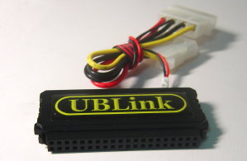
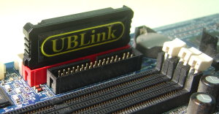

Administrator Setting
User’s Manual

http://www.ublink.org
Table of Contents

I . Preface 1
1 . Appreciation 1
II . System Requirements 2
1 . Network Requirements 2
2 . Hardware requirements 2
3 . Client End S/W Requirements 2
III . Installation 3
1 . Harware Installation 3
2 . BIOS Setup 3
3 . First boot 3
4 . IP Setup 4
IV . Quick setup 7
1 . Login 7
2 . 4 Steps 9
V . Management Interface 14
1 . Mail Server 14
i . Basic Setup : 14
ii . Management of Queue : 18
iii . Outgoing Signature : 19
iv . Mail Attact Defend : 20
v . Greylisting AntiSpam : 22
vi . Greylisting Log : 23
vii . Mail Recorder Logs 24
viii . Setup 25
2 . Virus Scan 27
i . Quarantine 27
ii . Setup 28
iii . ClamAV Engine 28
3 . SPAM Filter 29
i . Setup 29
ii . Learning of Advertisement Mails 32
4 . Policy Filter 35
i . Standby for Verification 35
ii . Delayed Area in Sending 36
iii . Deleted Log 36
iv . Filtering Rules Management 37
v . After Process 41
vi . Sender Limit 41
5 . Account Managing 42
i . Accounts 42
ii . Group 45
iii . Application Checking 45
iv . Default 48
6 . LDAP 49
i . Basic setup 49
ii . Co-Address Book 50
7 . Additional Servers 55
i . DHCP Server 55
ii . DNS Server 55
iii . WEB Server 57
iv . FTP Server 60
v . MySQL Server 61
vi . SMB File Server 63
vii . Proxy cache Server 65
8 . Networking Setup 67
i . Network Status 67
ii . WAN Interface 68
iii . LAN Interface 69
iv . PORT Define 69
v . DDNS Client 70
vi . Simple Firewall 70
vii . NSLOOKUP Tools 72
9 . System Setup 73
i . Page Styles 73
ii . Managers 74
iii . Power Management 74
iv . Remote Backup 76
v . Initial BackupHDD 77
vi . Creation SSL Certificate 77
vii . System Update 78
10 . System Log 79
i . System Eventlog 79
ii . SMTP Log 79
iii . POP Log 80
iv . Network Log 81
v . FTP Log 82
11 . Logout 82

Preface

Appreciation
First of all, we sincerely appreciate you at your kind choice on our product. The UMail Dom is a system especially designed for microminiaturized Linux configured system. That’s so easy to power on the system and begin its service automatically. The system will use Web interface to proceed all the controls on the functions. Even though the administrator is far beyond the other end of the earth, you may go ahead to navigate the server’s content and proceed your management and setup jobs by an internet computer .
The UMail Dom allows you to adjust your harware requirement freely according to the number of end users spreading in each department unit. No matter it’s the most simply pc system or the multi-CPU server system, the UMail Dom will automatically detect its config and activate it without any special setup by manual.

System Requirements

Network Requirements
To build up the Network, you may use a fixed IP ADSL leased-line, or a PPPoe dialing up. We would suggest you to choose the fixed IP ADSL leased-line.
The Dynamic IP is not proper to construct the Mail Server.

Hardware requirements
A X86 level of PC or Server whose CPU supports Intel or AMD’s chipsets must also support one CPU or multi-CPU configured computer. Besides, the Host must be equiped with an IDE type of CD-ROM driver and you may assign the system to be powered on by the CD-ROM driver.

Client End S/W Requirements
The cliend needs a Window OS system with built-in IE6.0 or above, or FireFox nivigator to set up the server and/or backup beyond.

Installation
.

Harware Installation
The UMail Dom is perfectly supporting the IDE HDD device.
The UMail Dom supports most of SCSI card devices except RAID devides. Especially it doesn’t support most of the RAID spec devices of IDE and/or SATA. So please take a pre-test in compatibility whenever you are going to use these devices.
The UMail Dom doesn’t support SATA RAID (south-bridge chipsets) on board, for example, the raid of Intel ICH 7R is not a pure HDD raid which can be used in the system of windows only. The Linux system doesn’t support it currently.

BIOS Setup
Please check the Host’s BIOS first when powering on if its power-on priority has been set up by CD or not. Moreover, please also check if the HDD has been installed well.

First boot
You will see the following screen whenever the HDD is installed well and the computer is rebooted up:
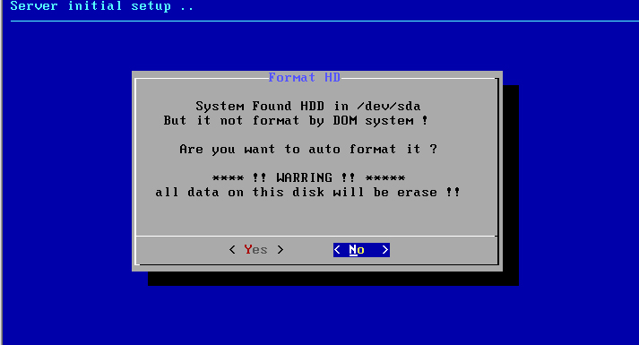
After confirmation, the system will remove all the HDD data and format it into the readable system format by UMail Dom.
The followed inquiry from the system is that how many sections you need for SWAP. Nomally, it is set up to 512MB or two times of RAM capacity installed by you.
We recommend you to set up it to 512M~20484M.
The system will automatically complete the HDD segment and reconfiguration then reboot up by itself.

IP Setup
After rebooting, the system will remain on the page of “Server is Ready” 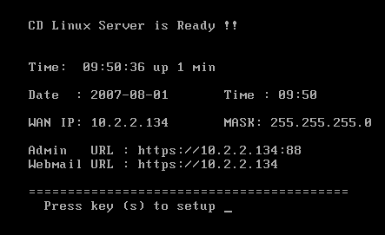
which means the power-on is completed, referring to the following:
「WAN IP」：it’s an IP for linking outside. Every system needs at least one Network card for connecting. You must set the UMail Dom at the WAN end, even it’s installed after the firewall.
「LAN IP」：Whether you set up it or not, the segments of LAN and IP must be different. But if the LAN Network card is installed and set up completely, the system may own the functions of NAT and essential firewall as well as ‘ proxy cache server’ to offer you a faster internet performance.
Should the IP is not shown on the screen, then it could be some mistakes as below :
1. Incompatibility on installion of Network card : When you power on the system, you’ll see one IRQ list from the BIOS report. The screen page will disappear in a blink of an eye. Please press the ‘Pause’ key to stop the screen and observe that if the motherboad can connect with the Network card and indicate the right IRQ default or not.
2. The Network card ver. is too new to be supported: Please replace the Network card , or disable the bios and then change the card.
3. Your IP is incompatible with the other computers’ IP : Please change your IP.
4. The pppoe is not connected in dialing : Should you use the pppoe dialing way for connection, please make sure with the right account number and password. Otherwise the people by dialing is over the max numbers allowed.

Press “S” and enter the IP page for detailed setup as below :
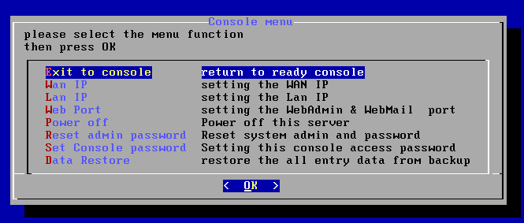
「WAN IP」：you may make the IP setup of WAN end in this option. Please choose STATIC(fixed IP ) , DHCP( gaining IP by DHCP) , or ADSL pppoe in dialing way as you like.
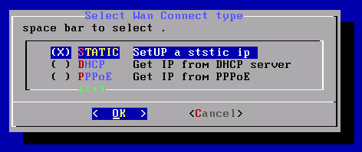
「LAN IP」：the Network card of LAN is not a must. But should you install two Network cards in the UMail Dom, then you will have the following functions : DHCP server, NAT , firewall , proxy cache , and internet login restriction.

「Power off」: you may execute the order in the option of ‘console’ to power off the server.
「Reset Administrator password」: this action will recover your account number and password to the default – A/C No. : admin - Password : adminpw
「Set console password」: should you have set up the password, then you must enter the designated password by you and enter the setup page of console.
「Data Restore」: please follow the screen page’s operating instruction to proceed the restoration of system backup data

Quick setup

Login
The default of managing interface is ‘https://serverIP:88’ on ‘, for example , https://192.168.1.1:88 .
As to the ‘server IP’ is exact the 「WAN IP」or 「LAN IP」 designated by you in the option of ‘console’.
Note that the ‘s’ must be added after’http’ as ‘https’, which means that all the transmissions are processed with encryption of SSL-128bit.
Please ignore the following screen page, and press ”Y” to continue. It’s because that your domain has not been certified by CA yet. Generally speaking, the unpublic usage( for internal staff only ) doesn’t need the CA certification.
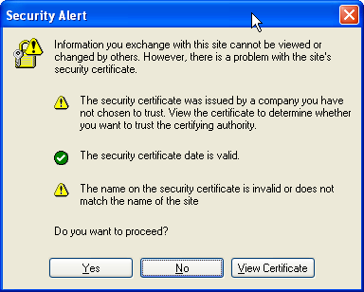

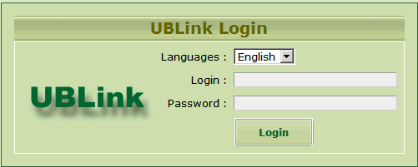
Whenever you finish the system installation, you may use the default values of managing interface to log in :
login ID : admin
password : adminpw
* Please note they are all in small letters not captial letters.
When you log in the Web, the navigator’s cookie function is necessary. So please setup your Privacy page as below :
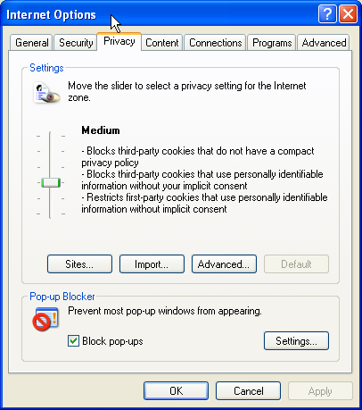
You may not worry its safety as any of your login data of account and password will not be recorded down.

4 Steps
Should you use this system the first time, please make a swift setup to ask the mail server to receive/send mails by the following steps :
1. IP Setup : 『Networking Setup』＝＞『Wan Interface Setup』
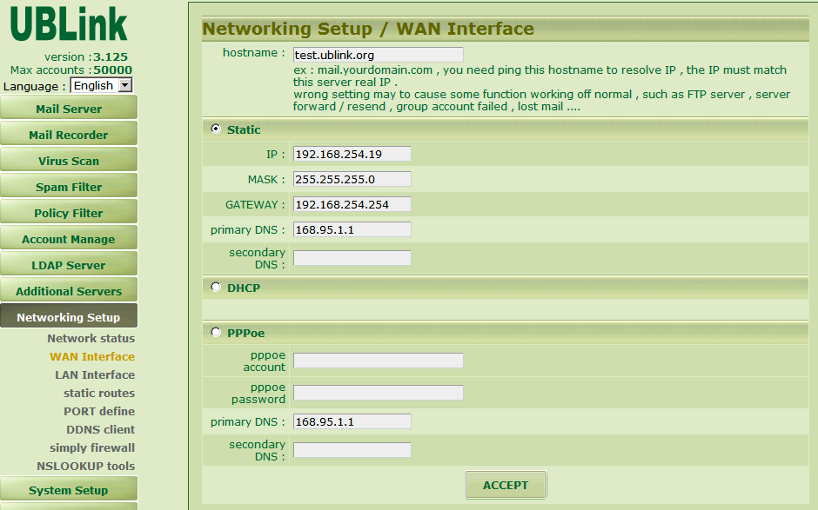
You may set up your IP according to per your network environment. As long as it works fine to link to internet properly after setting up, you may use this function of 『Networking Setup』＝＞『Network status』to check if the line works well or not.
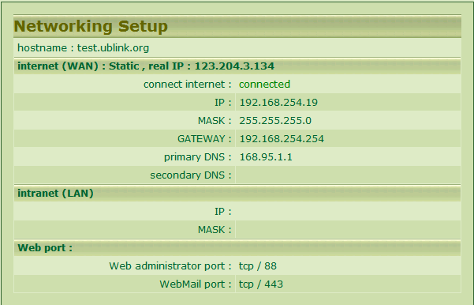
If it （connect internet）displays : connected, then the current IP & gateway setup of your system can connect the internet. Moreover, when the real IP is displayed, it means that you are using the correct DNS( normally it is recommed with ‘hinet DNS, 168.95.11’ and ‘168.95.192.1’ ).

2. DNS Server Setup : 『Additional Servers』＝＞『DNS Server』
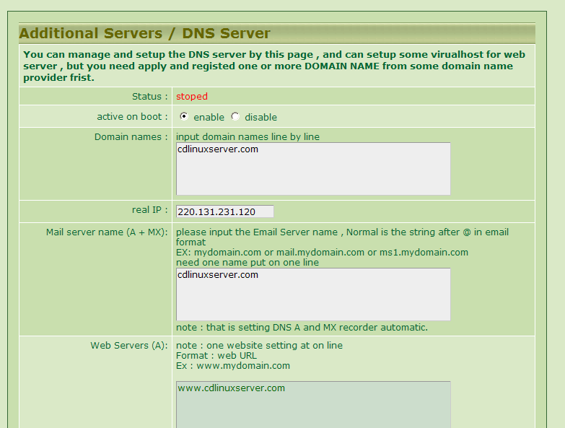

Domain Name : Please enter your domain names line by line if you have many of them. The correct entering format is 「mydomain.com」not 「www.mydomain.com」. The 「www」has to be removed.
real IP : Please enter your real IP. Normally the system will detect and fill in it automatically.
Mail Server Name : Normally it will be the same as your domainname, i.e., the part behind @. For example, if you hope that your email address as 『xxx@mydomain.com』then you fill in the part with 『mydomain.com』or you may fill in with 『mail.mydomain.com』to meet your email format as 『www@mail.mydomain.com』
Further advanced setup of DNS please refer to the following sections.
3. Mail Server Setup : 『Mail Server』＝＞『Basic Setup』
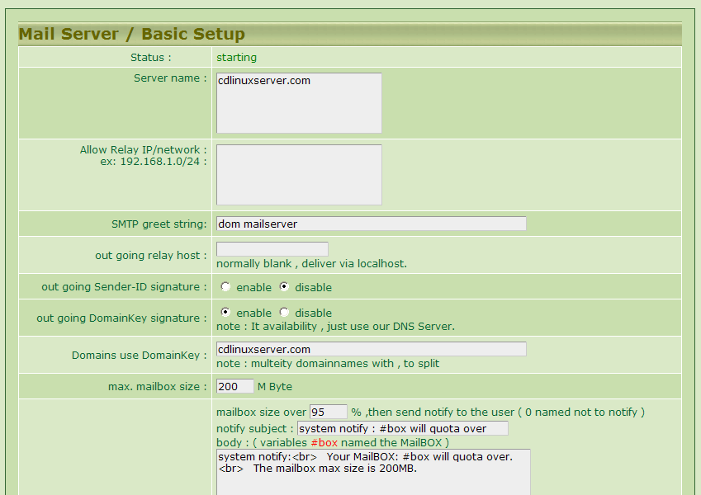
Server Name : Please enter the same Mail Server Name as last paragraph in the same column.
Allow 『Relay』Source : Normally, it is not recommended to fill in this column（the default is to use the account and password for mail identification）. Supposed that it is needed, please fill in 『192.168.10.0/24』 which means that you may send mails during the area of 192.168.10.1~192.168.10.254 and need no verification. For example, when you fill in only one IP as 「10.2.2.1」, the source IP doesn’t need any verification to send mails.
Further detailed setup please refer to the following sections.
4. Build an Account : 『Account Manage』＝＞『Accounts』
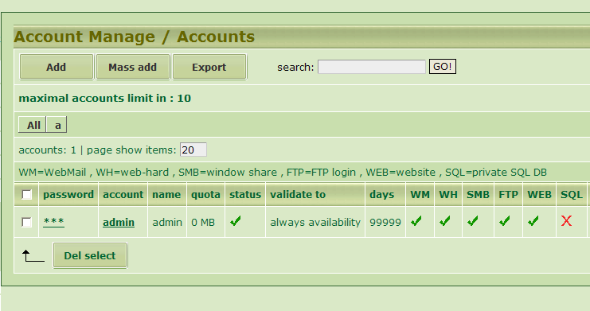
Press the button 『Add』, enter all the basic data on the scree page and a new account is built , for example :
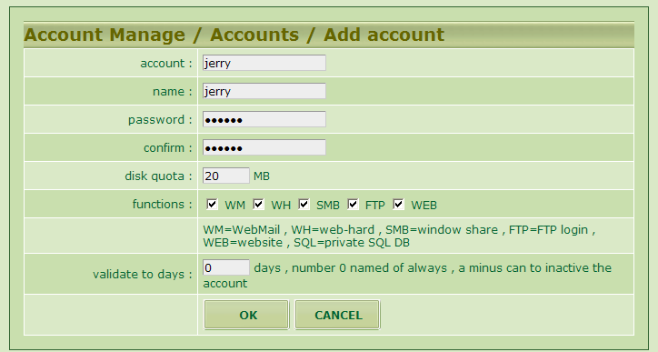
To build a new account : jerry, and the capacity allowed is : 200MB.
Now you get a new email account in your server. People may send the mails to jerry@mydomain.com. The email address of jerry can receive the mails properly.
Your domainname above is assumed 「mydomain.com」.
5. For Client ( The User ) to Receive Mails :
You may use the mail receiving software as Webmail or outlook/express.
. Webmail : Please visit website https://mydomain.com.
Log in with account name as 「jerry」and the password of jerry built just now.
Outlook : Please make the setup as ususual, but the verification is a must when sending mails. So, you have to pay attention to the setup option of 『My Server needs to be verified.』as below :
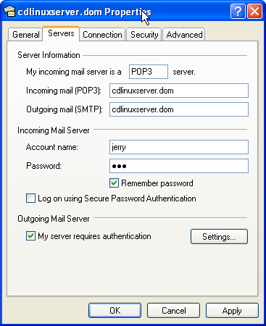
Check there
There are total 4 Mail Receiving Protocols supported here as : pop3 , pop3s , imap , and imaps. The 『s』adhered to the protocals’ ends represents they are encrypted during transmission.
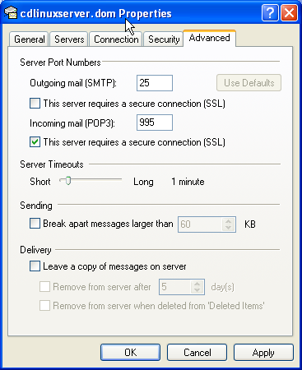
Check there if use pop3s

Management Interface

Mail Server

Basic Setup :
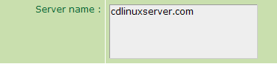
Please give a name to your Mail Server. Should there are many names, then fill in the name line by line.
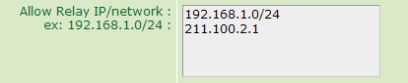
To set up the sending source of mail without prior certification. Normally, it is recommended to keep this column blank. However, there are two formats allowed to assign the source, the 1st one : you may assign some IP directly, ex., 203.217.109.112; the 2nd one : you may assign some range of IP as 「192.168.10.0/24」representing「192.168.10.1~192.168.10.254」. All the IPs during this range are allowed to send mails.
When the clients communicate with your mail server, you may use the 『telnet』to test your 『server 25』
Result :
Normally the mail will be sent out by the host directly without any prior setup. However, there are some exceptions here, ex., you cannot send out the mail directly for unknown reason, or for the limitation from your ISP. In this case, please key in your Outgoing Mail Server Name in the rectangle box, ex., key in 「msa.hinet.net」.
You may pin the 『msa.hinet.net 』first and fill in the got IP address. However, you have to make sure your internet provider is 『hinet』first and obey the ISP regulations.
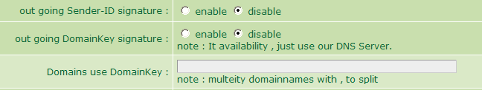
This version will support two kinds of lincence for outgoing mail.
1. Sender-ID / SPF : It’s a kind of Anti-Spam mechanics from Microsoft.
2. DomainKey : It’s a kind of Anti-Spam mechanics from yahoo.
It’s quite easy to be activated. First of all, you have to use the host to manage your domain name （details referring to the parts of 『Additional Servers』＝＞『DNS Server』）, and then select this option for activation. Finally please fill in the domain name column of 『domainkey』 with your domain name.
Test : Send one mail to the other’s server and ask him/her to open the mail to check if the following message is displayed or not :
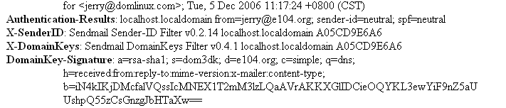

By the way, you have to check if your DNS server is working properly and offering the domain information or not. Test method : open a『cmd』window.
To diagnose the test with『nslookup』: please enter『nslookup』.
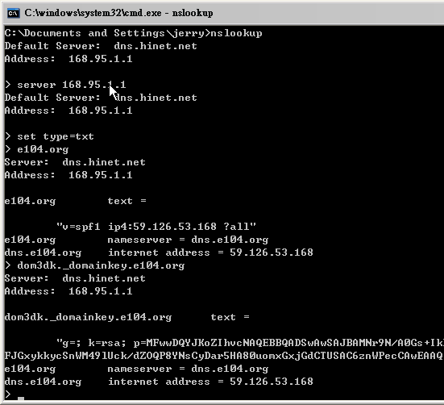
check configure for sender-ID
Check configure for domainkey
In the picture above, the 「>」means the line for keyin. Please change the 『e104.org』to your 『domainname』for testing according to above procedures.

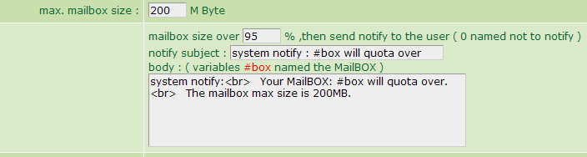
Please set up a single 『Inbox』（including a personal Inbox）, 『max. mailbox size』and an auto notification function whenever the mailbox is going to be full.
Note : Whenever the mails are over its capacity and the user takes no action, the system will separate the mailbox automatically, for example, the mailbox will be moved into another section named『INBOX.1』 to receive the mails continually. But supposed that all of the user’s capacity available is full completely, the system will return the mail to the sender directly.
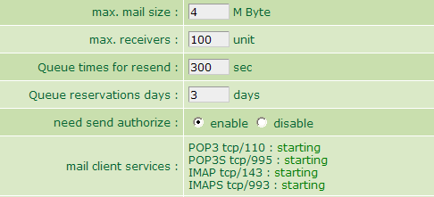
They are some Parameter Settings for the Mail Server’s operating parameters above.

The receiving end of mail supports 4 kinds of communication protocols. Two of them , the『pop3s』and『imaps』, are encrypted with『ssl 128bit』 when transmitting. They are the best ones for the travelling staff on safely mail receiving. If the following screen page is displayed when receiving mails : 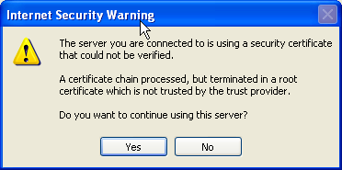
Please select button「Y」. It’s owing to the domainname has not been certified by『CA』. Most of the「Mail Servers」 are offered to the employees for working only, so the『CA Certification』is never needed.

Management of Queue :
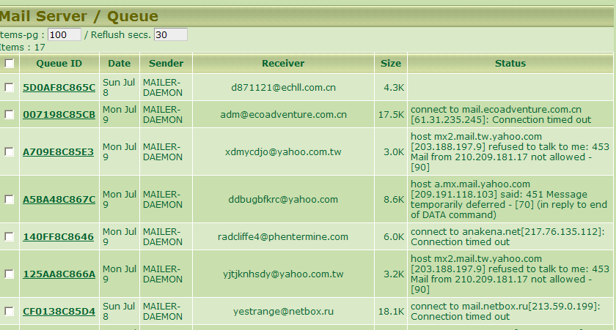
The mails will be listed in the Queue table for some reasons :
1. There are so many mails coming in simutaneously and they are waiting here for priority arrangement.
2. The server at receiving end fails to serve temporarily, so they are waiting for resending.
Usually you will see the returned mails of 『user unknown』. Most of them are faked senders by『spamer』, which causes a phenomenon of no address to return the mails. You may ignore them normally. Should such kind of mails are so many（say hundreds of them at the same time） in the Queue table, please decrease the setting of days in Queue table（details as last chapter）.

You may check the mail’s content by clicking on the mail’s Queue ID.
You may also select the box of Queue ID to delete it.

Outgoing Signature :
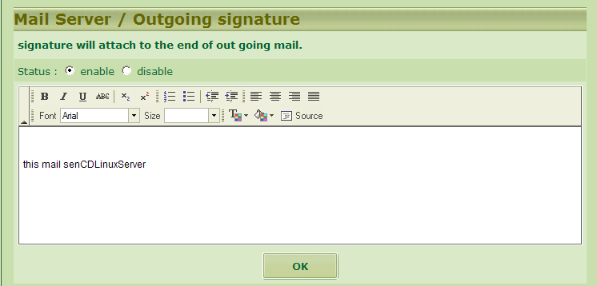
The「Outgoing Signature」will be attached to the end of the sent mail to indicate the mail source or non-liability declaration.
The「Outgoing Signature」here supports the HTML syntax.

Mail Attact Defend :
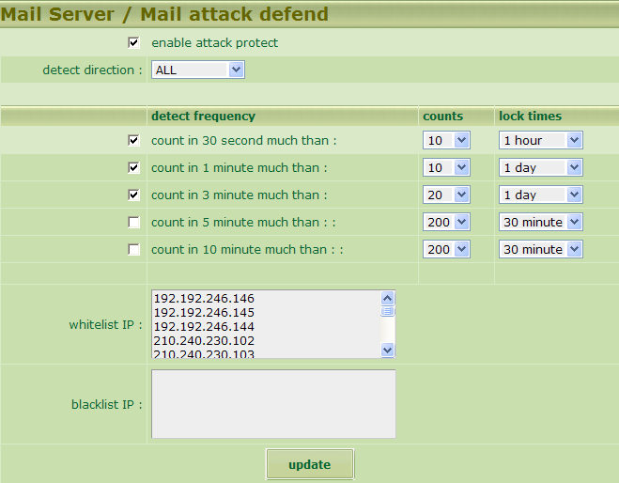
Detect direction : the direction to be detected
Detect frequency : the frequency to be detected. You may make different setting conditionally and time locking to different frequencies respectively by selecting different options on the screen.
Whitelist IP and blcaklist IP : It may set up the imperative passage IP or imperative interruption IP respectively.
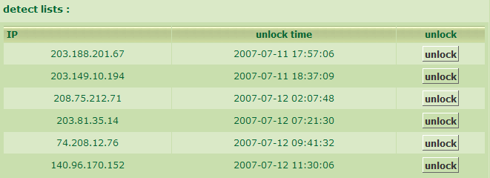
Whenever any of the above interruption settings is met, then the server will interrupt the IP linking for a while at once, referring to above picture. You may also unlock this command as you like at any time.
This function will either protect your Mail Server from any fixed point source attacting perpetually in a short time, or effectively and efficiently defend your Mail Server and interrupt connection instantly from sending mails out consecutively just because of some internal IP infected by the virus of 『PWSteal.Trojan』.
Note : This function doesn’t replace the protection performance of the full-functional firwall completely.

Greylisting AntiSpam :
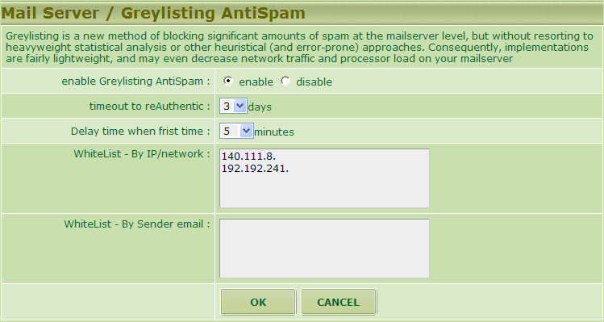
『Greylisting』is a fresh new method on AntiSpam. So far, most of the Spam senders are using informal Mail Servers. And such kind of mail sending programs will be checked out easily by『Greylisting』.
Principles of 『Greylisting』:
1. Sending Spam Mail －＞Mail Server
2. Any source mails meet the definition in the『Whitelist』are accepted.
3. Any source mails other than the『Whitelist』will be requested to resend later ( it will be applied to the first communication from the company. )
4. Should the mails be sent from a really true Mail Server, then it will resend the mails later. Whenever the mails come, the Host will record down its source IP.
5. Should the opposite side is a sending program ( advertisement ) and will deem it is an invalid Server and jump over it to continue its sending job.
6. The recorded down Mail Server IPs will be kept for some days and deleted.
Even though the above functions, the『Greylisting』has some defects. For example, supposed that the opposite side is not listed in the『Whitelist』and the mail comes in the first time will be delayed for some time ( say few minutes to one hour ) to let us receive the mial. By timing cosideration, it’s not applicable to the units with time limitation.

Greylisting Log :
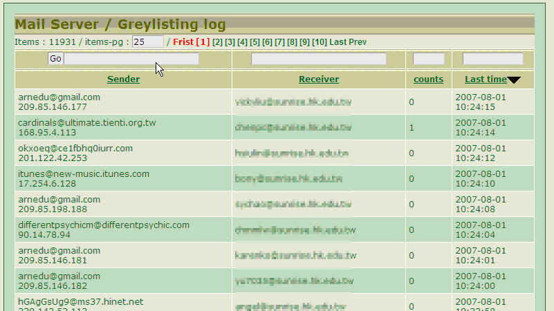
You will see all the logs of coming in mails as above, when the mentioned 『Greylisting』is activated. The『Times』shows 「0」meaning the first coming in , so them will be allowed to enter after a while.
This function is very useful and helpful to those Servers under busy loading, so the Spam Mails will be reduced a lot.
Mail Recorder

Mail Recorder Logs
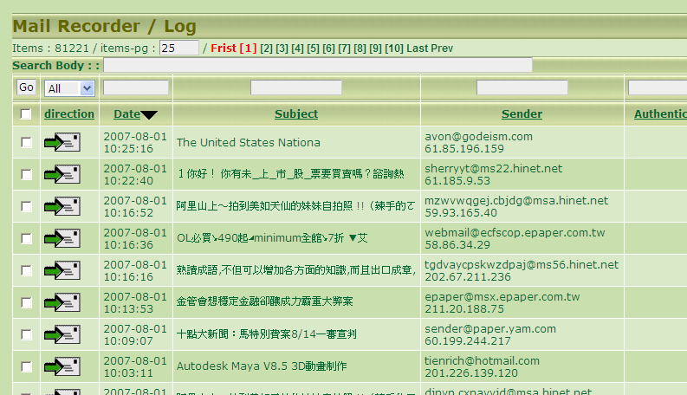
The 『Mail Recorder』will log part of the in-out mails during whole session for inquirng onwards.
You may click the『Subject』column to open the mail and check its content.
You may enter the「letters/words」in the blank rectangle box and press button『GO』for inquiring.
It is not recommended to delete any mails in the『Mail Recorder』, because the『Mail Recorder』will delete the overloaded mails by itself. Please refer to the next section for details.

Setup
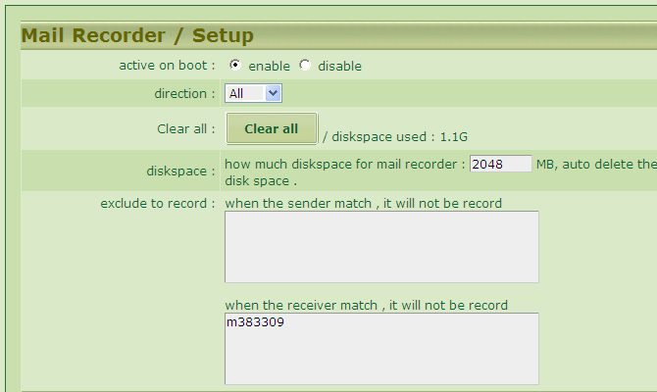
The 『Mail Recorder』,『Recorder’s Direction』and 『Recorded Object』 can be decided by you on whether activated or not.

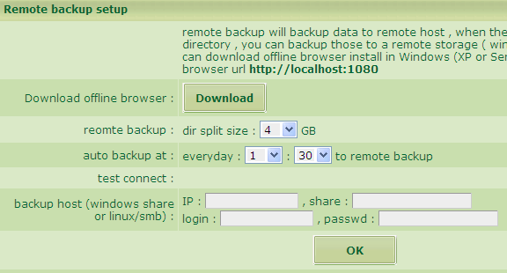 The『Mail Recorder』can backup the mails in a remote storage device somewhere else. For example, the default 4G directory represents that every 4G capacity can be burnt to a DVD diskette for permanent storage and for future inquiry.
Note : The remote backup data somewhere else can be only inqured with an『Off-Line Navigator』. Please click『Download Off-Line Navigator』button and download the program of 『apserver.exe』, then install this program into your backup server. You may just follow the screen page’s instruction to execute http://localhost:1080.
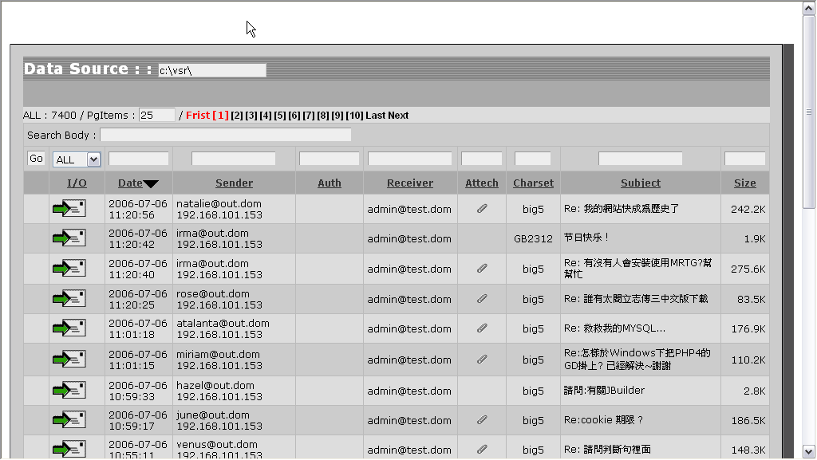
When entering the system, please assign/enter your『Data Source』as『DVD /Backup Data Path』.

Virus Scan

Quarantine
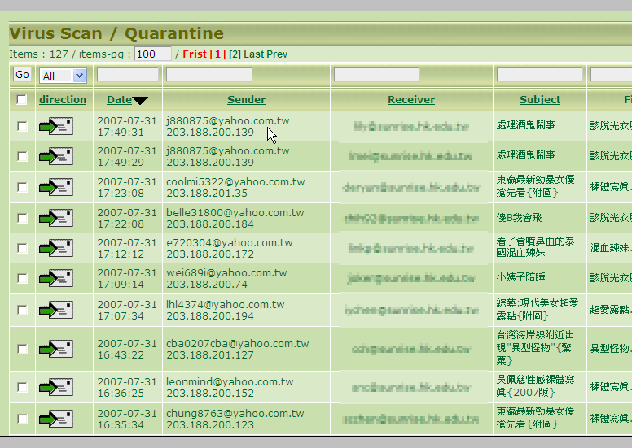
When the quarantine policy is set up, then all the mails detected virus will be moved to this area.
So please pay much attention to the mails in the area, when you plan to download any mail from this area to avoid any possible virus infection.

Setup
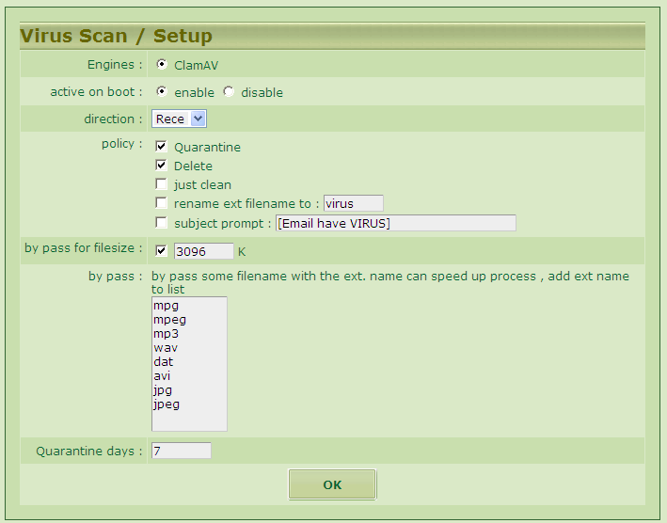
Please make a setup as the scree page’s options. To use the default setup options is recommended.

ClamAV Engine
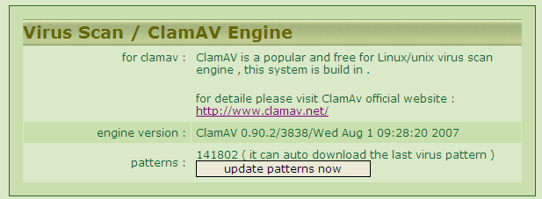
ClamAV Engine is a package of virus scan software. It’s built in the system and will update the virus code and scan the virus periodically.

SPAM Filter

Setup
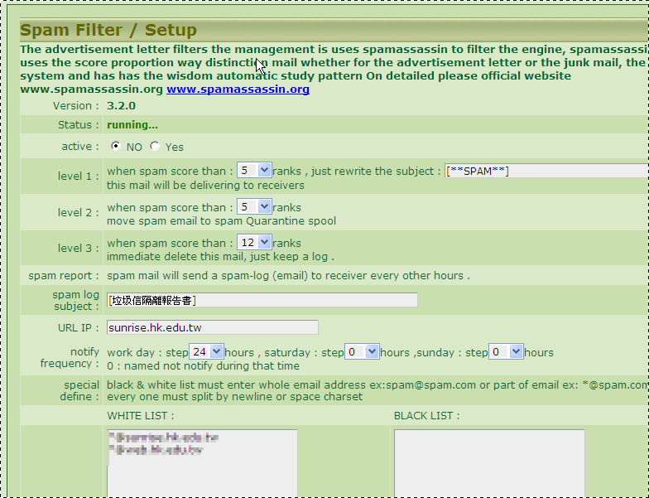
This is one of the most important functions from『UMail Dom』. If only you use the Emails for a while, you’ll find that half of them are not the ones you want. We call them as『SPAM』or 『Advertisement』. The longer you use the Email account the more『SPAM』will be received. It becomes such a tiresome job on receiving mails, because that you must percolate the really useful mails from a lot of『SPAM』. Here is a good news for you, i.e., the『UMail Dom』may filter the『SPAM』for you automatically. Besides, the setup is very simple and easy to help you on resolving the hot potato and it works exact one of your private secretary.

The『UMail Dom』is using a kind of advertisement filter engine as 『spamassassin』which is free and known as the most functional device of advertisement filter. The『spamassassin』is based on the 『Bayesian Analysis』which is a kind of analysis especially for statistics. Wehever the mail is received by the system, the『spamassassin』will make an analysis of behavior model on the mail accompanied with a judgement reading according to the database of historic learning. Moreover, an 「Advertisement Possibility Score」will come out for the mail. Generally speaking, the range will be during 0~100. The figure is larger the suspicion is more possible. And then the administrator or the user will set up different levels of mail manageing policies by differently possible suspicion scores. Let’s illustrate our configuration policies designed for the 『UMail Dom』as below :
Generally speaking, the score is over 10 deemed「Advertisement SPAM」. The warning score level is up to your decision and setup.

First, the system will grade every mail according to the database analysis a SPAM score. Second, the system will give a public setup or a filting policy for individual user and then proceed deletion or quarantine.

After cumulating the SPAM for some time（it’s up to you）, the system will send a SPAM report to the individual user.
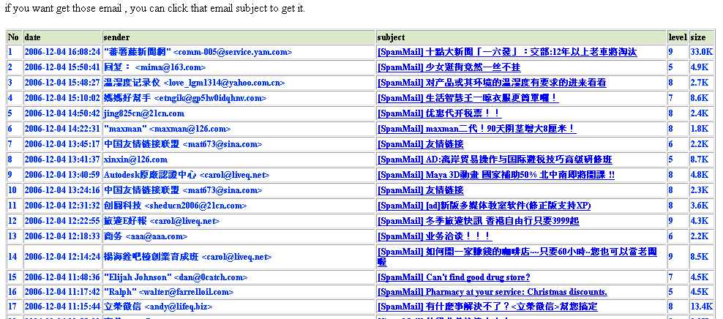
The above records are located in the area of quarantine. You may click the button 『subject』to receive the mails again. They will be deleted automatically after the set up date.
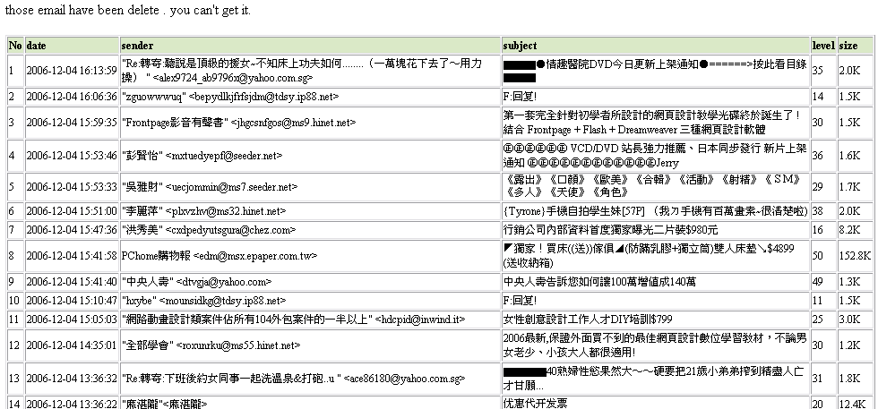 The grey parts mean the mails deleted. It’s because their SPAM scores have over 3rd level. So they are deleted directly and only the records left here.

When there is no any new setup made, the identification rate by default value may reach 85%. However, the following two methods will allow you to increase the rate of identification :
1. Setup of blacklist and whitelist
You may use wildcard of “*”, for example,「*@yahoo.com.tw」 or 「*.com.tw」.

The 2nd method is adopting the learning mechanism, referring to the next section for details.

Learning of Advertisement Mails
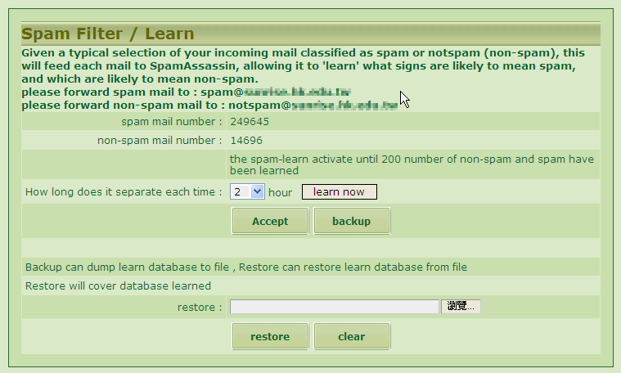
Note : The Learning System will be activated when the SPAM/NON-SPAM quantity reaches 200 pcs up.
The results of learning can be either transferred out of the database, or restored back for the utilization of『UMail Dom』.

With the mechanism of Learning Advertisement Mails will increase the identification rate.
Restoration : 3 methods
1. System Administrator : it uses the『Mail Recorder』and 『Filter Log』in the managing interface to restore the mails to SPAM or NON-SPAM.
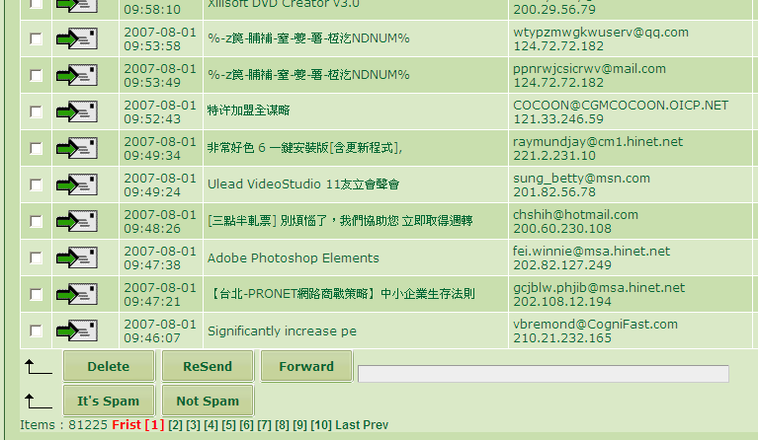
Please select the mails for restoration first, and click button『It’s Spam』or 『Not Spam』to complete the restoration procedure. Should the restoration be incorrect, please refer to the following example : supposed that your request is 「Not to restore the mail to SPAM」and the result is opposite. Now, please restore it again as「Not-Spam」.
Note : The database will be activated when the SPAM/NON-SPAM quantity reaches 200 pcs up.

2. The restoration of user’s Webmail
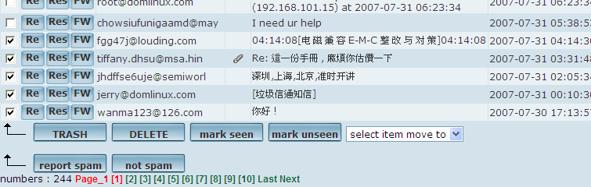
It’s all the same as above.

3. Restoration of Outlook Mail Software
When you are using the software of outlook or outlook/express, please select several mails each time and click button「transferred by attached files」.
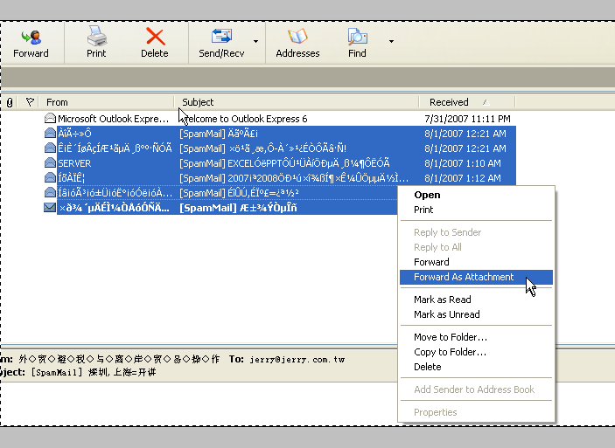
Besides, the mails have to be transferred to the following special accounts :
spam : for restoring and collecting SPAM.
notspam : for restoring and collecting NON-SPAM.

If you intend to restore the SPAM, then use the above-mentioned method to transfer the mails to ：spam@yourdomain; if you intend to restore the NON-SPAM, then transfer the mails to ：notspam@yourdomain. 「yourdomain」represents the Mail Server Name of your company.

Both accounts of 「Spam」and 「notspam」will only accept the source mails verified by their account identification ( internal staff or employees ) and permitted IPs. The reason is to avoid outside’s interference of intent.

Policy Filter

Standby for Verification
The system will compare the mail with your filtering rules when you activate the mail filtering rules. When the filtering policy is set up at『stop verifying 』, the mail will be kept in this Log Area termporarily and not be sent to the original receiver. Upon the mail verified by the system administrator or assigned person, it will be decided whether released or not.
You may click the button of「subject」to check the mail’s content.
If you want to verify and release the mail, then just select the mail first and click button down 「PERMIT」to let the receiver get the mail at once.
Supposed that an inspector is assigned when setting up the rules, the inspector will receive a verification request mail with the following content :
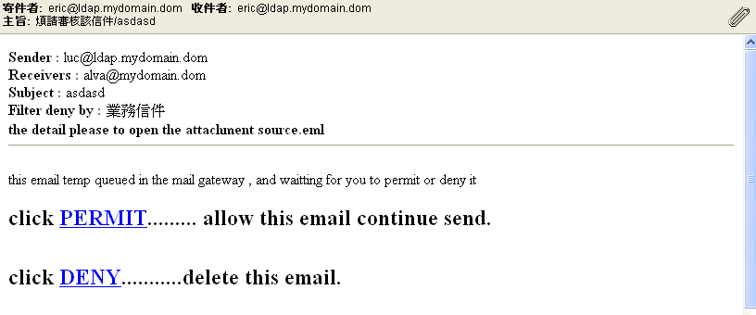
The above mail will be sent by attached file, please open the attachment.
If only the inspector click 「PERMIT」then the mail is allowed to be sent continually.
If only the inspector click 「DENY」then the mail will be deleted.

Note : If the mail is not verified all the time, then it will be kept in the verification list area forever until the administrator deletes it; if it is verified and it will be kept in the list for a while, no matter it’s permitted to be sent continually or not. It will be judged either deleted or moved to the Mail Log area according the reserved duration setup from『After Process』next section.

Delayed Area in Sending
The system will compare the mail with your filtering rules when you activate the mail filtering rules. When the filtering policy is set up at『delayed sending 』, the mail will be kept in this Log Area termporarily and not be sent to the original receiver. Upon the default date/time up, it will be sent to the original receiver.
Please refer to the section of 『Filtering Rules Management』for detailed setup.
The mail will be kept in the Log Area and be judged either deleted or moved to the Mail Log area according the reserved duration setup from『After Process』.

Deleted Log
The system will compare the mail with your filtering rules when you activate the mail filtering rules. When the filtering policy is set up at『delete this email』, the mail will be kept in this Log Area termporarily and not be sent to the original receiver. Upon selecting the mail in the managing interface and clicking the button 「send」, the mail will be sent out.

The mail will be kept in the Log Area and be judged either deleted or moved to the Mail Log area according the reserved duration setup from『After Process』.

Filtering Rules Management
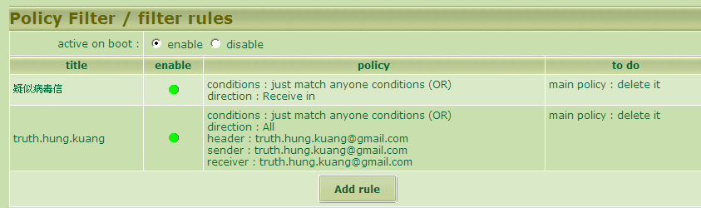
The function of『Filtering Rules』will compare the mail with the rules set up by order of up to down. Whenever any rule is met, it will stop comparison. So you must arrange your rules setup by important or exclusive order.
You may edit your rules order by click button of 『add new filtering rules』or 『according to current filtering rules』
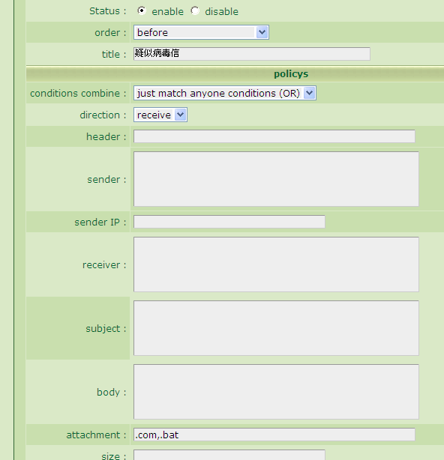
Activation Status : activated or not activated
Executed Order : to set up the executed order by conditions, the prior one will be executed first.
Filter Name : it’s used for verification; the rule will be labeled when the mail meets the condition.
Conditional Policy
Collumns of Conditions : please enter the sample.
『,』 : 「OR」
『+』: 「must, AND」
『(…)』means to combine the conditions configured with another condition set.
Whenever the content of the columns meets『confidential』…

Whenever the content of the columns meets 『confidential』or 『important』…

Whenever the content of the columns meets『confidential』or 『important』, the word of 『drawing 』is a must as well.

Whenever the content of the columns meets『confidential』or 『important』, the words of 『drawing 』or 『file』are must as well.

Whenever the content of the columns meets『confidential』and 『important』, 『drawing 』and 『file』…

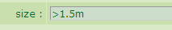
Whenever the mail capacity is over 1.5MB, you may apply 『>』, 『<』, and
『k, m, g』as the unit.
Currently this system doesn’t support the configuration as 「>1.5m+<2m」.

Configured Conditions : you may use『AND』（all columns must be met）, 『OR』（partial columns are met enough）
Mail Direction : you may focus on the setup of 『in/out』or rules comparioson to all the mails.
Head Content : all the messages attached to the mail’s header
Source IP : IP of coming in/sending source
Sender : comparison to the Sender’s Email
Receiver : comparison to the Receiver’s Email
Subject : including the characters
Mail Content : comparison to all the mail text
Attachment : comparison to the attached file name; note : not comparing to the content of the attachment.
Mail Capacity : comparison to the mail’s capacity

Executed Policy : the major policy
None : no executing the major policy, but transference and reply.
Delet this email : To delete the mails directly, it will be logged in the deletion area.
Stop Verifying : The mail will be stopped first and you may assign a certain person to verfity or release the mail. Besides, the administratora may log in the interface to do release action. The mail will be kept in the area of 『Standby for Verification』temporarily.
Delayed Sending : The mail will not be sent out and released until the postponed or fixed duration set up coming.
Transfer to : You may set up the one assigned to receive the copy mail.
Auto Reply : You may set up the auto reply function to reply the sender as well as the subject and the content.

After Process
There are three major filtering policies ( stop verifying, delayed sending and delete this email ) allowed to be set up with the reserved duration in the Log Area. You may assign the days to be reserved and the handling method of 『After Process』for each setup may . You may choose :
Delete this email : Delete this mail from the server thoroughly.
Move the Mail to the Mail Log Area : Move the mail to the Mail Log Backup Area for keeing it forever.

Sender Limit
You may use this function to assign individual user, limit and control the use of the email information. Moreover, the administrator may set up the control of some user on either sending or not sending the information to a certain receiver or domain .
For example, the two users of jerry and kaven can only send mails to the internal not the external.
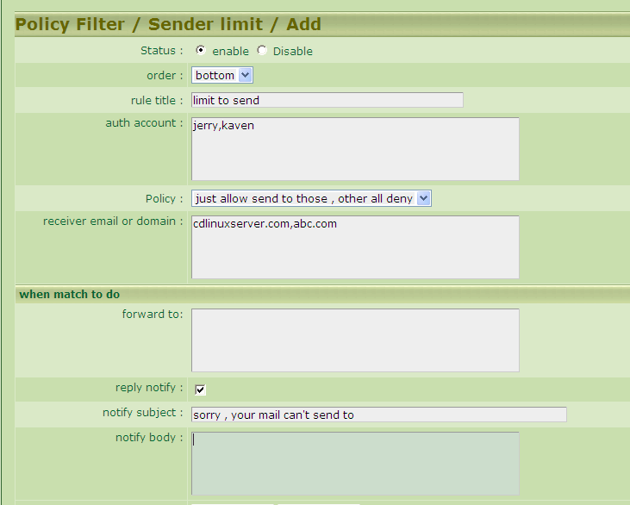

Account Managing

Accounts
『UMail Dom』let you manage the server users easily.
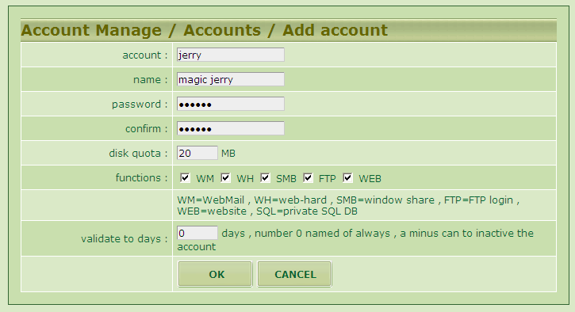
You only need to enter the data according to the instruction on above screen page and you’ll get a new account.
When adding a new account, you may utilize the allowed quota space of the account to store your Emails or personal network HDD- FTP, and construct personal website. Even you may decide if the user can use these functions or not.
Set up the availabe days of this account : You may set up how many days allowed for this account. If only the duration is up, this account will be locked and stopped at once. In case it is not recovered within a period( referring to the default ), the system will delete it automatically.
When the account is deleted, the system will retrieve its capacity and delete all the data.
If the user is allowed to use the SQL database, the system will buid up a database with the same name as the account automatically. Meanwhile, the database administrator will add a new user’s account with the same name and the password of the new account will follow the password setup of the user.
For example, a new user named「jerry」who is allowed to use the SQL function, then the system will add a database named「jerry」. Besides, a new user of the database is also named「jerry」whose password is the same as 「jerry」’s. The new user can only manage this database.

This function is applied when the user intends to install a set of website program「php+MySQL」within his account space, ex. phpBB , XoopS …, the steps for installing is as below :
Compress the program「phpBB」in the windows environment first.
Log in the IP address of Server「ftp://server」by way of 「ftp」.
Copy the compressed files to the personal「ftp」directory 「_www_」.
Enter the personal website 「http://serverp/~jerry/」
Start the installation program of「phpBB」. Whenever the installation progrme inquires the setup concerning to the database, please refer to the following :
host : localhost
database name : jerry
user of database : jerry
Password of database : same as jerry’s

After all above steps, you have been swiftly installed a website program supported by「php+MySQL」under a personal website. Should you don’t want to install it in a personal website, you may set up a correspondence between the user’s capacity and the website name referring to the system setup as the Web Server setup functions of DNS, as :
www.mydomain.com
Details referring to『Additional Server』－＞『Web Server』and 『DNS Server』.
Volume Of Accounts : You may build up volume of accounts. There are three ways to build it .
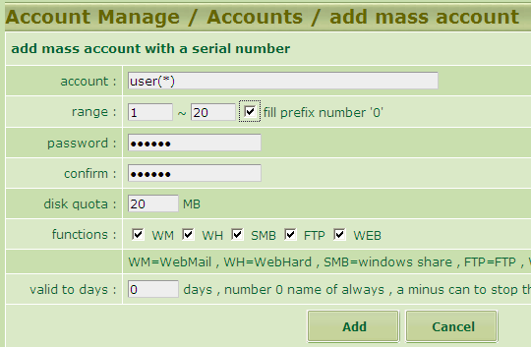
By Serial Number : You may enter the data as the rules of「user(*) , user(*)_aa…」where the 「(*)」is a replaceable variable which can be replaced by 01,02,03…etc.
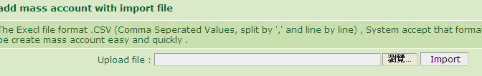
Re data transferred by format of 「csv」file, you need to edit a file in「csv」format first and transfer it from the interface. Please refer to the sample on above screen page concerning the「csv」format.
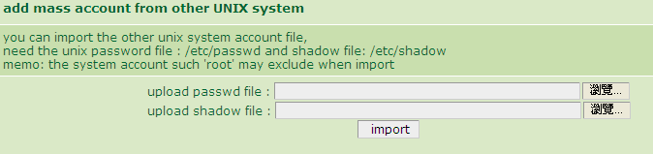
『Unix』Account Transferring : You may transfer the account compatible to the『Unix』account, for example, system account of linux , freebsd , sun solaris , aix …etc. Normally, you need two account files to complete this action, one is「passwd」and the other is「shadow」. Generally, the two files will be located under the system’s directory of 「/etc」, for example, the shadow file of「freebsd」is 「/etc/passwd.master」.

The password of the transferred account may be the same as original.

Group
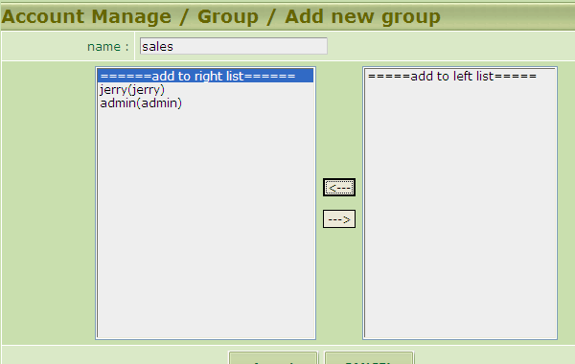
The group of 『UMail Dom』uses an alias to represent several accounts. When the mail sent to this alias, all the accounts assigned in this alias will receive the same mail. For example, you may add a new group and name it as「sales」then select all the people concerning sales into this group. In this case, all the relative sales users selected will receive the same mail when a mail is sent to「sales」.

Application Checking
What a hard work it is to buil up accounts ! Why don’t you ask the users to fill in the application form by themselves ? So, the administrator will be responsible for checking only.

For example, you may ask the newcomer to apply his/her own account by himself/herself, and fill in the basic data. So the administrator will only answer for checking and releasing what functions and capacity quota allocation allowed for those who apply.
Please click apply form『EDIT』button to revise the application form.
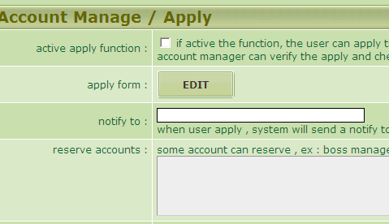
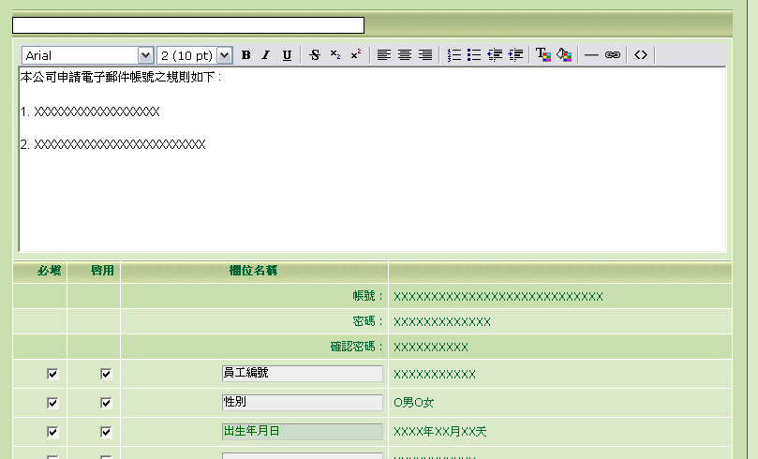
All the columns can be redefined by yourself except the account and password columns.
Remember to activate the form function :
You may access the application form from the Webmail homepage : https://xxx.xxx.xxx.xxx

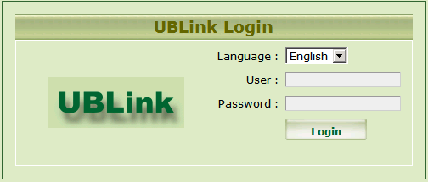
Click button『Apply』to fill in the application form.
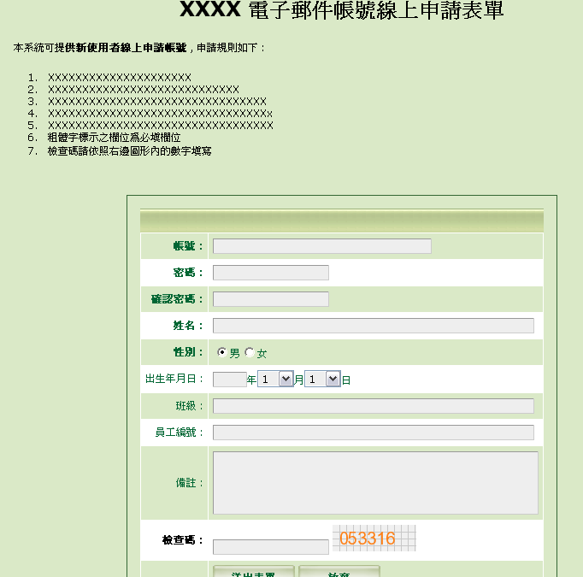

The administrator may execute account checking through the managing interface.
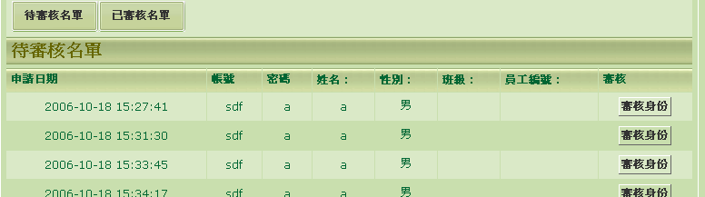

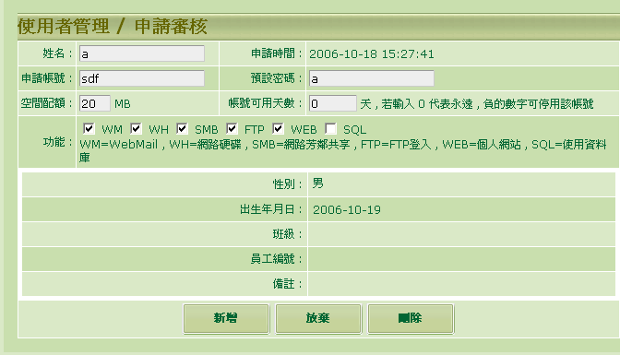

Default
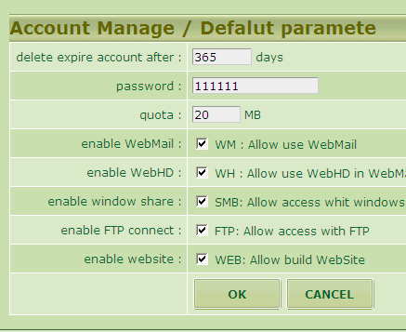
You may set up the default values for a new account, so you don’t need to change the values of ecach columns.
The overdue account will be deleted automatically : You may set up whenever the duration of the account is expired and not re-used then it will be deleted automatically.
It’s quite useful for the student accounts at school. For example, you may give the freshman a 3-year duration and it will be deleted automatically when he/she is graduated. So you the administrator doesn’t need to worry and work on deleting one by one.

LDAP

Basic setup
『LDAP』can be used to build up the whole groups or the 『Co-Address Book』in the company. This Book is available to the Webmail or the Outlook.

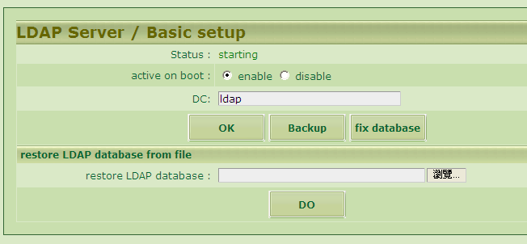
Please decide if you want to use the『LDAP』service or not, default as「activate」.
The『LDAP』 file can be back up and restored back by interface in the future.

Co-Address Book
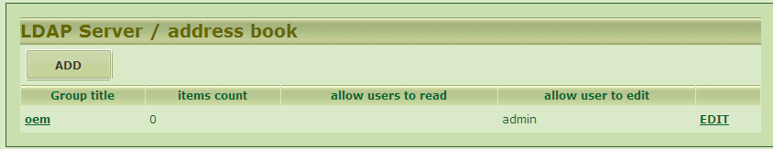
Each group is equal to an Address Book. You may set up which people can use the Address Book and edit it.
The default allows all the accounts in this host to read the Book. Only the administrator has the right to edit it through the managing interface.
Some people assigned with editing authorization can edit the Address Book under the Webmail interface.
How to edit the『LDAP』Address Book under the Webmail interface :
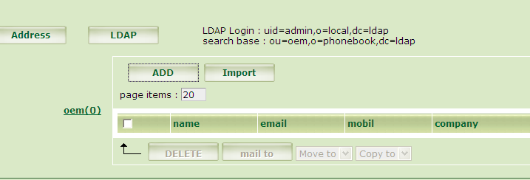
using the setup parameters needed by outlook
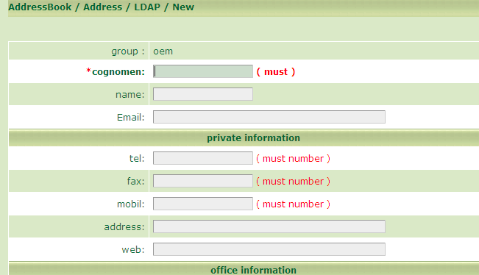

Applications under Outlook :
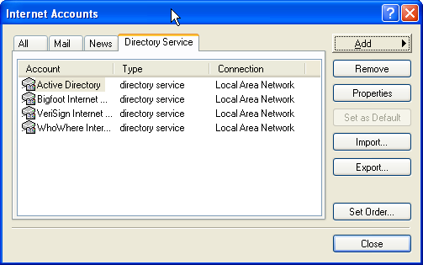
Service of Choosing Directory :
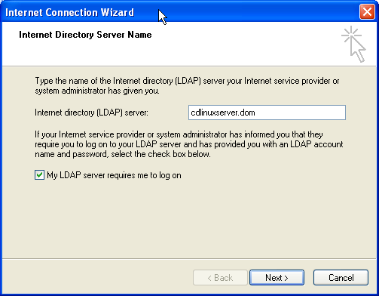
Check the item of 『My LDAP Server』to ask you to log in.
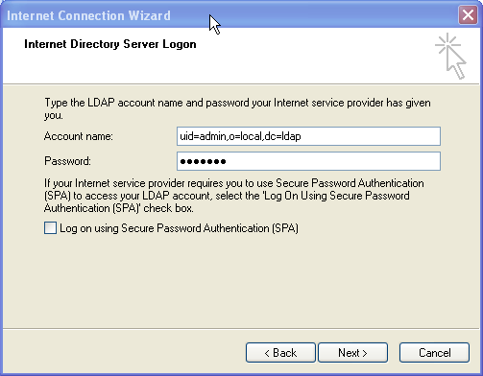
Please refer the Account to the Address Book of Webmail LDAP.
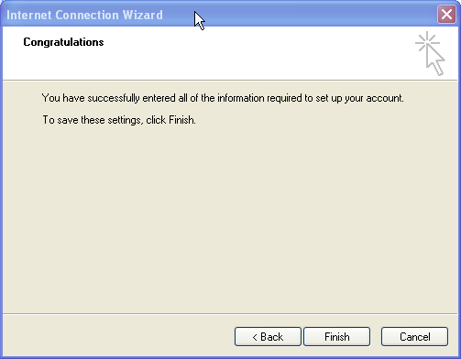
Please enter the page for editing again and select button『Advance』.
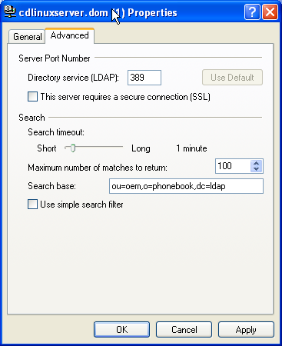
Please enter the『Seaching』data to the Address Book of Webmail LDAP.

When you want to write an Email, you may inquire the LDAP Address Book directly instead of traditional default Address Book in your system
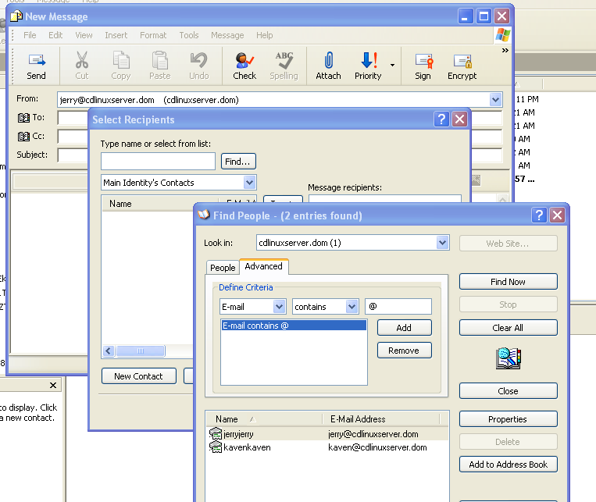

Additional Servers

DHCP Server
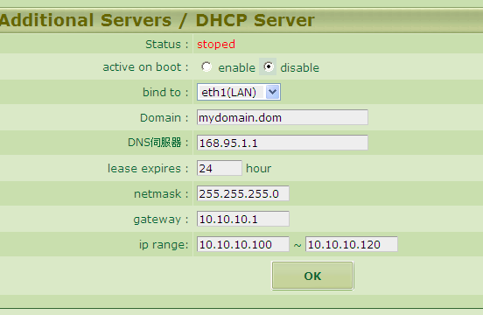
The DHCP Server may be responsible for dynamically releasing the IP at Cliend end.

DNS Server
Even we’d ever mentioned 『DNS』in Chapter IV. 2., we’ll give you a further complete illustration here. To have a well setup of『DNS』for the Mail Server is such an important matter, or a lot of weird issues will come out when receiving mails in the future. For example, you may not receive the mails, or wait for a long time to receive them, or receive them irregularly as sometimes getting mails and sometimes not.
Supposed that your company has appled two DomainNames as『a.com.tw』 and『b.com.tw』respectively.
One IP address is『1.2.3.4』for『UMail Dom』, the other one is belonged to WebHosting by another ISP as『www.a.com.tw』by name and with IP address『11.22.33.44』. Then please set up your DNS Server as below :

Doubtless you have to switch your『DNS/Host』direction back correctly from the ISP where applying DomainName in advance. Please refer to Chapter IV.2. for details.
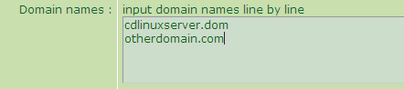
Please enter the two lines『a.com.tw』and 『b.com.tw』into the column of DomainName. Remember not to enter『www.a.com.tw』, because if it is with『www』then it is not called『DomainName』.
在對外真實IP輸入 : 1.2.3.4
External Real IP Address : 1.2.3.4
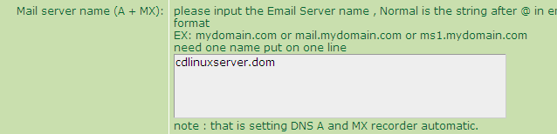
Column of Mail Server : Please enter『a.com.tw』and 『b.com.tw』by two lines.
In this case your Mail Server have two names as『xxx@a.com.tw』or『xxx@b.com.tw』. Both of the names can receive mails in the future.
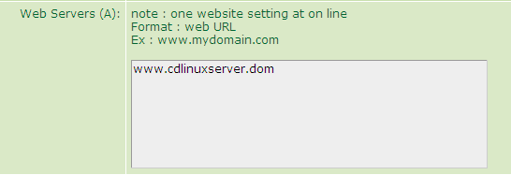
Column of Web Server : Please enter the『A』records of Domain, then try if you may ping the IP address of 『www.adomain.com.tw』or not.

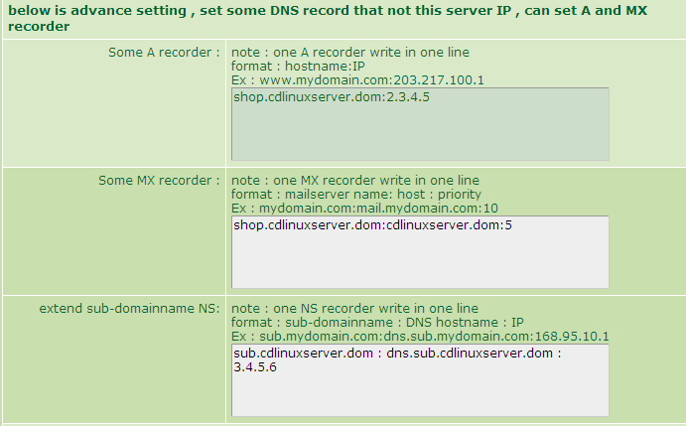
The following two setups are used whenever you company has other server, or supposed that your website is located at the Virtual Server Website controled by the other ISP, you may assign the IP address to the other server through these setups ( referring to above screen page ) .

WEB Server
Web Server allows you to build several Websites, limit the bandwidth and numbers of connection respectively, and confine the authority of using『PHP』Website language.
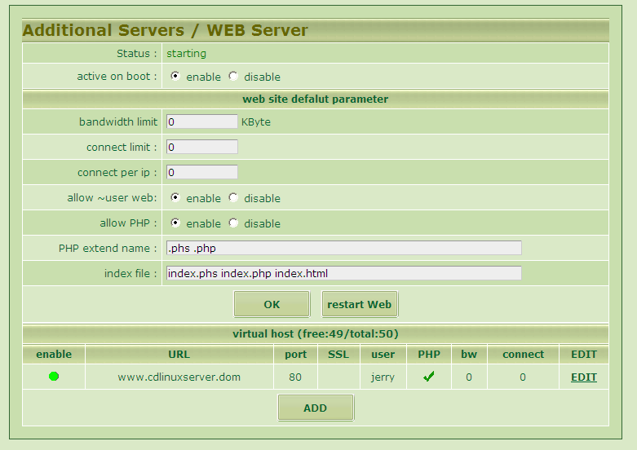
Please click the button『add』on the screen as above.
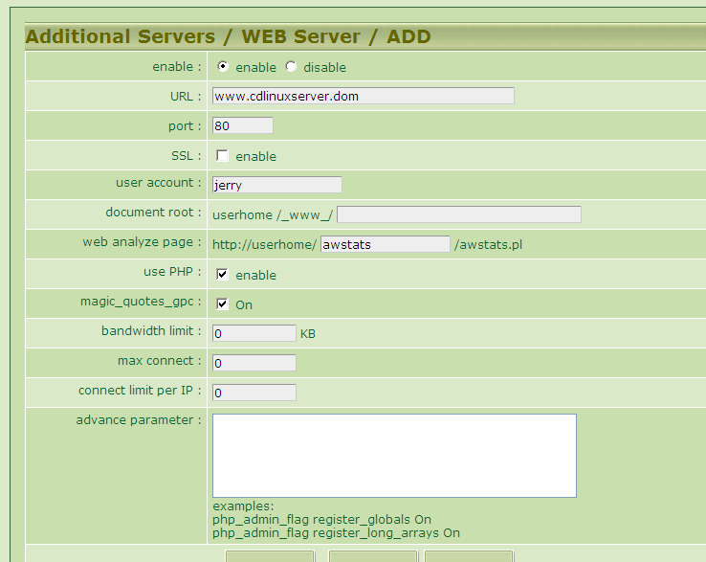
The default value of port number is『80 port』and no SSL is activated. If you use SSL then please change the port number.
User’s Account : Assign the Website Capacity User.
Directory : Please build the『/_www_』 under the user’s directory. Normally it is kept blank. Otherwise, you may use『ftp』to enter this page to add any newly assigned directory.
Website Analysis Directory : Every Website will issue an independent report as below automatically :
Please enter『/ awstats/awstats.pl』in the blank of the Website Analysis Directory Column.
The Website Analysis will be refreshed every half an hour. You’ll see the informations of Website flow rate, visitor numbers, sources…etc. from the Website Analysis.
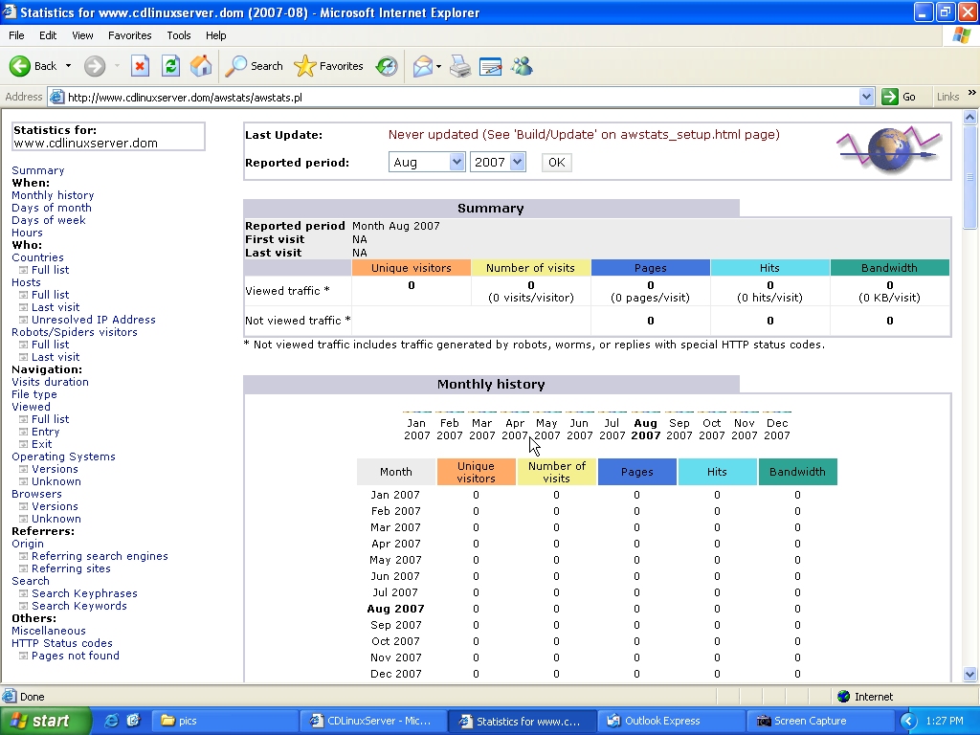
Application of 『PHP』: This function may decide if the『php』syntax can be used here or not.
magic_quotes_gpc : It’s a kind of 『php.ini』setup. You may also use it to set up individual website, referring to the relative information of 『php』website for details by yourself.
Bandwidth Limit : It may limit the width of the Website connection bandwidth to avoid one website spoiling all the others.
Advanced Setup : You may make some relative setup of『php.ini』, but please add『php_admin』in front of it.
For example :
php_admin_flag register_globals On
php_admin_flag register_long_arrays On

Note : The faulty setup may cause no server of Web Server wholely. So please do check all the setup methods concerned when setting up.

FTP Server
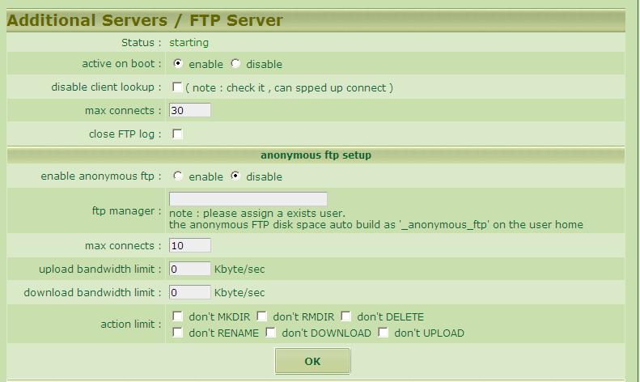
The『FTP』has two ways to log in as『Client FTP』（personal ftp）and 『Anonymous FTP』.
It also supports the user’s setup and management of Virtual FTP.
It may allows you to set up respective bandwidth and authority.
It allows you to utilize a Virtual User on controlling multi-space of the Virtual Users by a real user. This function is very helpful to the company who needs to release space/capacity to the subcontractors on uploading data, like the printing industy, output service centers…etc.
Instruction :
Primarily, you need to create a real user for the host and then click button 『add』to have a new Virtual User.
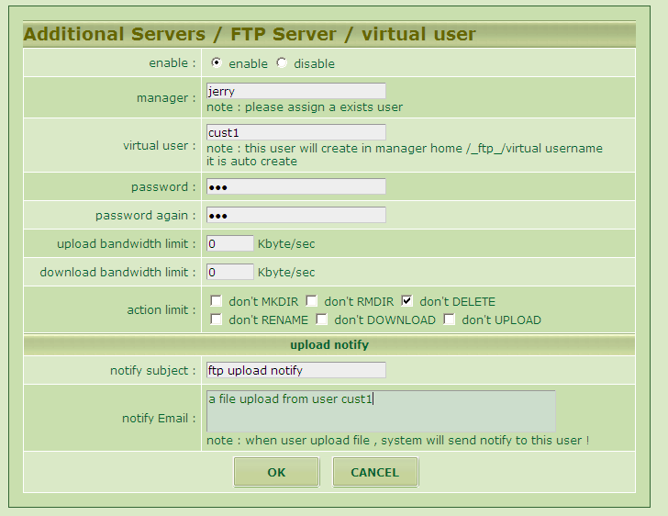
According to the above screen page, you may add a Virtual User to limit its authorization of not downloading files, uploading files, not allowed to delete files…etc.
When the user finishes uploading the file, the system will send an Email to jerry@e104.org with subject of 『FTP with uploaded file』and the content of its time, IP address, filename, size…etc.
Note : The system will notify you every 5 minutes. So the most deviation would be only 5 minutes from finishing uploading file to receiving notice.

MySQL Server
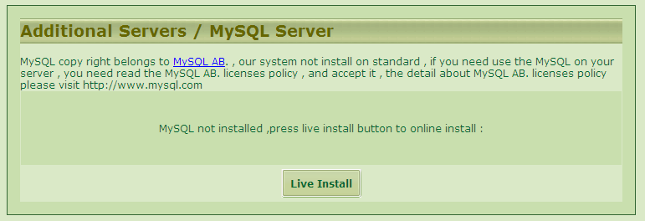
The『MySQL』 database system is not default in this system. Should you want to install 『MySQL』 then you must be sure that you fully understand its authorization scope. Generally speaking, most of the users and companies may use the 『MySQL』 database legally.
If you intend to install it, please click the button『Live Installation』as above screen page. After couple of minutes, the system will automatically finish installing and downloading it for you online. Once of installation is enough.
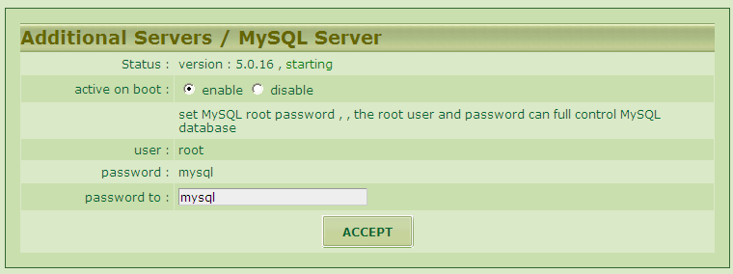
When you see the sceen above, it means the installation finished.
The function of 『MySQL』may be set up when you are adding new users on managing accounts to select the option of 『SQL』. And the system will build a database (DB) with the exactly same name as the user. Besides, a new database user ( db_user ) will be created and with the same name as the user. Even both of their passwords and account codes will be same. Further limitation will be on the user of accessing this database only.
For example, a newly added user 『abc』with password 『123』. Please select 『SQL』.
When you want to install an application software(AP) 『php+mySQL』 in the user’s space/capacity, you have to set up the AP’s database and you are requested to set up some information options as below :
Host = localhost

Db = abc
Db user= abc
Passwd = 123
If you are inquired about the version of 『MySQL』, please select『5.0x』.

In addition you may install the managing program of『phpMyAdmin』by yourself. But remember to change its『root』password of database and its limits of authority, or some unexpected errors will happen.
As to the newly added database accompanied with the duely added 『user』 will back up daily following the system backup every day. But the manually added database『phpMyAdmin』doesn’t have such a function. You need to back up it by yourself.

SMB File Server
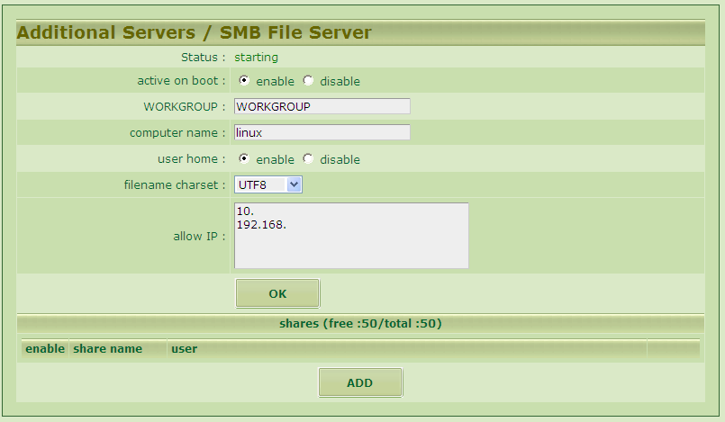
The function of 『Neighborhood』may have『UMail Dom』as a File Server to formulate the user’s group and limits of authority. For example, you may plan a share file which allows only three users 『a,b,c』to access it and only『a』has the authority to modify it.
Pleae click the button 『add new share name』.
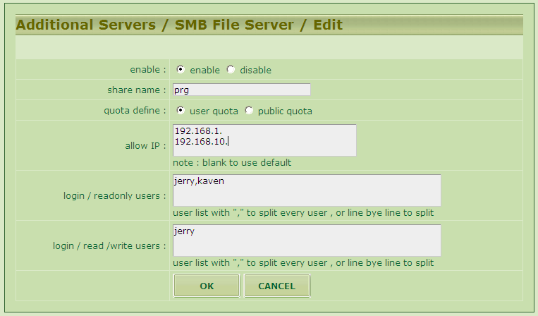
The newly added share name『prg』can be logged in via 『\\xxx.xxx.xxx.xxx\prg』, or linked networking HDD in windows.
Only the address scope of 『192.168.1.1 ~ 192.168.1.254』and assiged IP address 『192.168.10.100』are allowed for connecting.
Only the two users 『kaven』 and『jerry』are allowed to log in and use it.
Only『jerry』is authorized to modify/add files. 『kaven』 is allowed to access the files merely.

Proxy cache Server
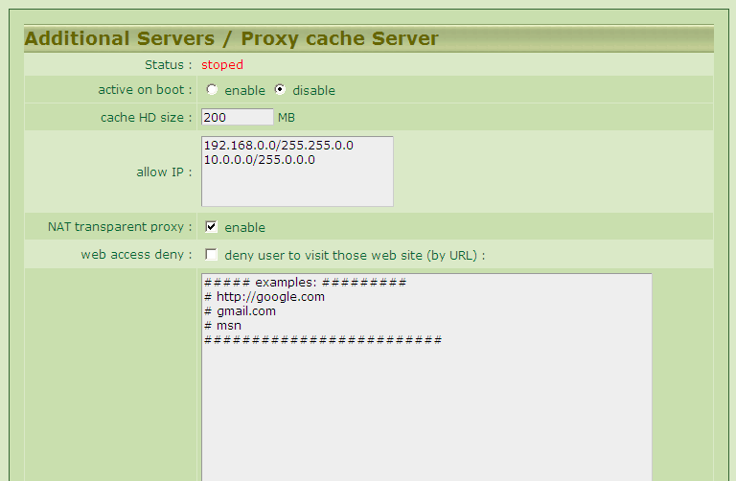
The 『Proxy cache Server』can fulfil two functions as below :
1. To accelerate the internet access :
The 『Proxy cache Server』will cache the internet access data in the Server. So whenever the next one intends to acquire the same data, the Server doesn’t need to derive it from the remote host in reality but send it to the internal users from its cache. In this case you may save your bandwidth and accelerate the speed of internet access.
2. Limitation of Internet Access :
When you activate the function of 『Limitation of Internet Access』, you may fill in the『partial website addresses』of the websites which you intend to ban them on the form. For example, if you fill in『google』 then you may not visit the 『google』for seaching. And you will see the screen as below when it’s not connected :

The port used by 『Proxy cache』is : 3128
If you activate the function of 『NAT』transparent agency, whatever computers under『nat』will be represented by 『proxy』automatically.

For the sake of safety, you must make a setup of permitting using the IP address for『proxy cache』service. Or may cause blocking IP owing to the opening of『proxy』function.

Networking Setup

Network Status
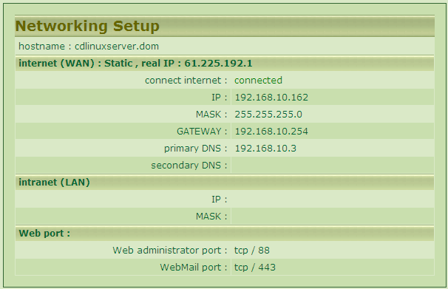
You may browse all the networking status of the Server currently. If all the outgoing connection is proper and normal, it means your internet may communicate with the outside correctly. Moreover, if your real IP address is displayed, it means the current 『DNS』used by you can proceed to analyse data normally.

WAN Interface
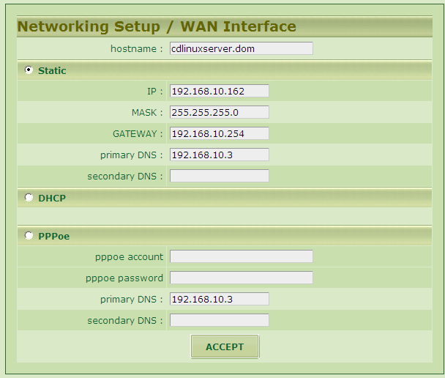
It may support fixed IP, DHCP or pppoe of telecom network.
『pppoe』is neither applicable in networking for MailServer, nor as a 『DNS server』.
You have to cooperate with the dynamic domain name service system,『DDNS』described in next section.
Note : If you only have one piece of network interface card, it must be set up as 『WAN』.

LAN Interface
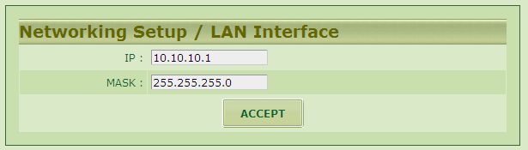
Set up the IP scope of the 2nd network interface card.

PORT Define
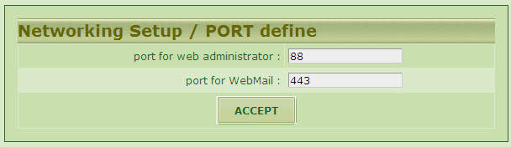
You may set up the port for connection of the managing interface and the WebMail interface.

DDNS Client
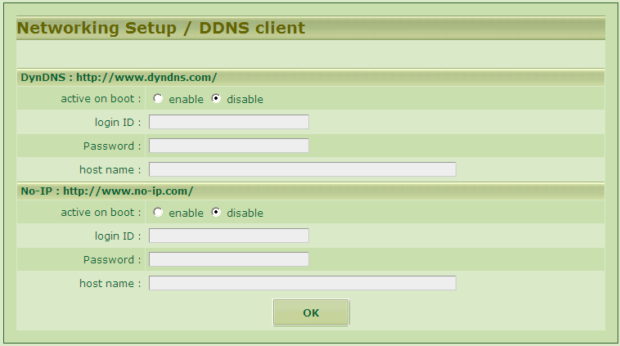
Both systems above are supported now. Please apply your accounts and domains at their websites by yourself, and then fill in their informations here.

Simple Firewall

The default firewall in the『UMail Dom』 has the functions of protecting the security of the Server itself, the isolating interface between the internal computer and the outside, offering the prot transference and assigning the sources.
Basic Setup : The functions of 『NAT』can be set up as either 『activate』or『shut down』.
Defense Setup : It’s a list of blocking the front sources.
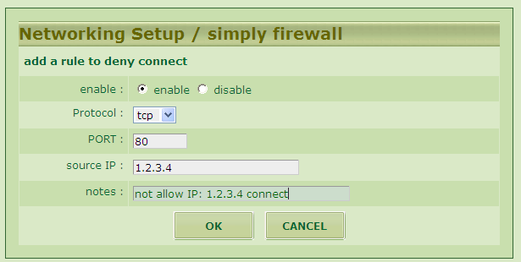
The above screen setup is to refuse the connection to your Web from the IP address of 『1.2.3.4』.
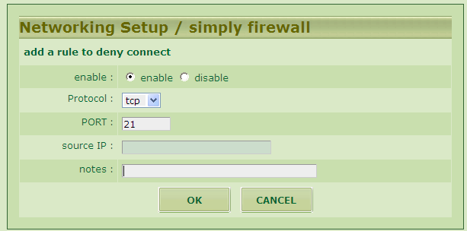
The above screen setup is to shut down the『FTP』service completely.

Virtual Service ( port forward ) will allow you to transfer the external 『service port』to a PC under『nat』, for example :
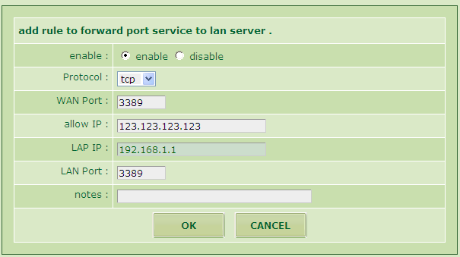
The above setup screen shows you that you may introduce the Remote Desktop Protocol (RDP) of windows to the internal IP address「192.168.1.1」of windows XP or server, and allow you to connect with the IP address「123.123.123.123」.
In addition you may assign no IP address to let all the IPs connect outside.

NSLOOKUP Tools

The『Nslookup』is a kind of inspection tool to make you inquire the『DNS』 from the server in order to judge if the『DNS』works fine or not.
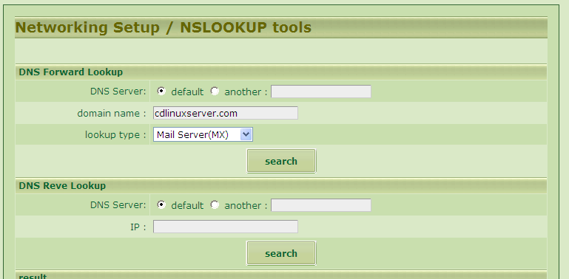
The result is :
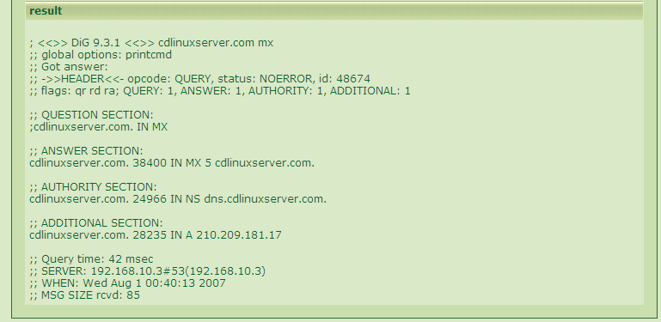
The searching consequence results in an explanation on the MX records of 『UMail Dom.com』.

System Setup

Page Styles
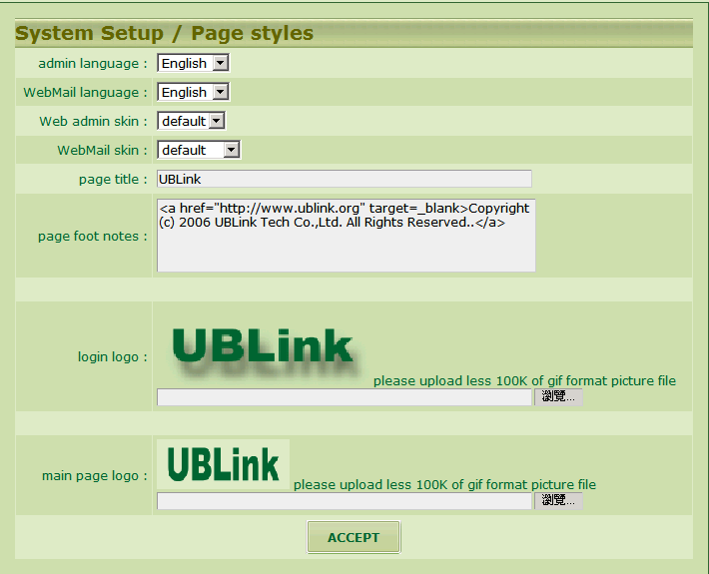
The unit who is using the system can apply this function to modify your picture of the major screen page and the footnotes.

Managers
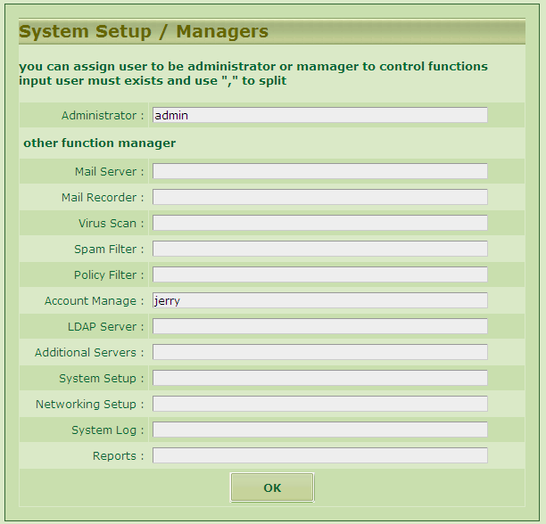
You may assign different user to share the management of the server. Should the account is assigned as one of the managers, the account cannot be deleted by the account administrator until the manager position is released.

Power Management
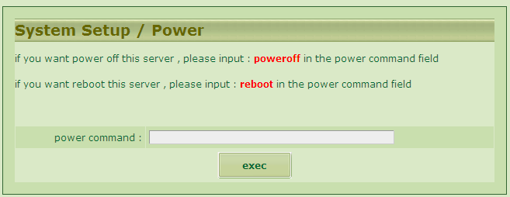
Please power off and reboot the computer according to the instruction above.
Note : This is a multi-CPU structure system. So the command of power off ( it’s a core limitation of Linux ) is not supported by the system. Whenever you give the command of shut down, the system will shut down all the services and not power off the power supply really. Therefore, please press the shutdown button on the power supply of the server when you are sure that the shutdown procedure is completed on the console page.

Remote Backup
The『Remote Backup』function will allow you to have several backup setups. Moreover, it may back up the system with a cycle by scheduled time.
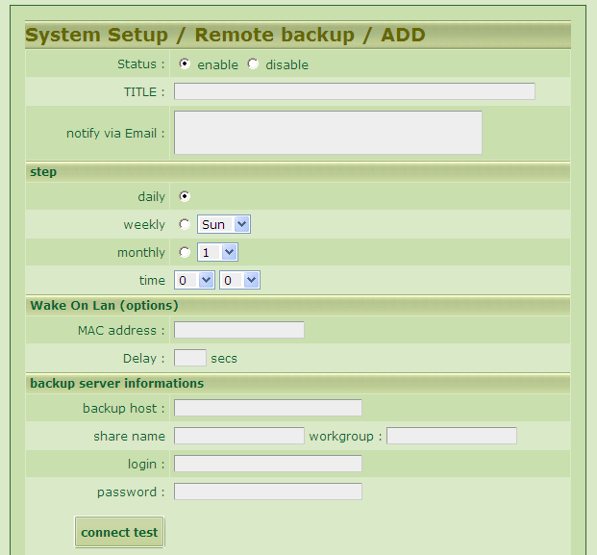
The Backup Host must be equipped with the share functions of 『Neighborhood』 , 『samba』or 『CIFS』. Moreover, the plan of a set of account and password to log in is necessary. The share capacity should be authorized with writing in.
The Backup Host doesn’t support the function of 『Domain Login』currently.

Initial BackupHDD
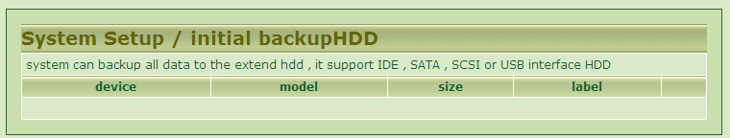

Creation SSL Certificate
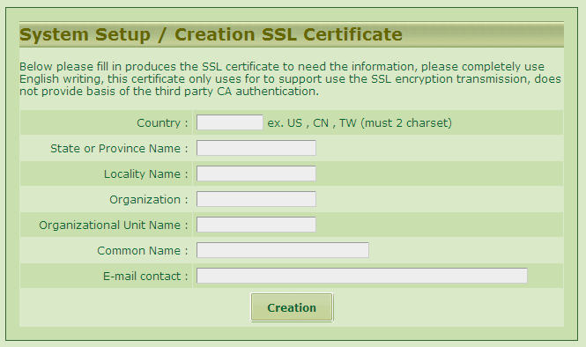

System Update
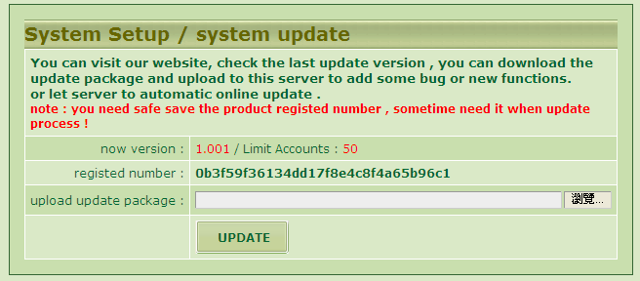
There are two methods for『System Update』:
1. By manual : You have to download the updated package and upload from this interface.
2. Auto Update : All you have to do is to click the option button 『Activate auto update』. Then you Server will inquire our update server in the system for any new version of updated information every one hour and complete the update procedure automatically.

Note : Most of the update needs no rebooting. Whenever measurable update happening to reboot the computer, the update system will reboot the system automatically and the update records will be put into the 『System Log』described next chapter

System Log

System Eventlog
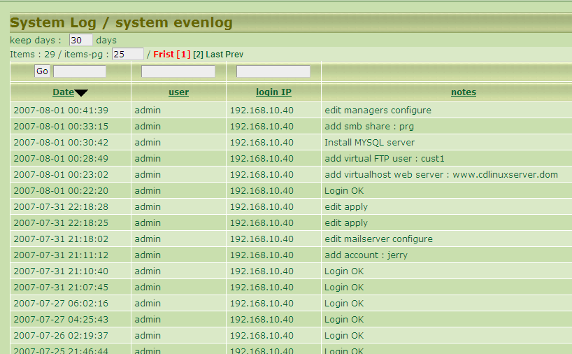
It’s about a list concerning all the operating records of the managing interface.

SMTP Log
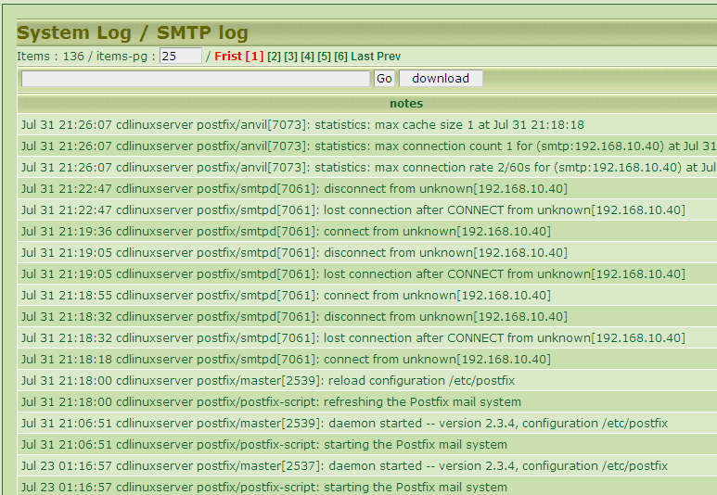
It’s a list of all the mail receiving records which will be remained for one month or so.

POP Log
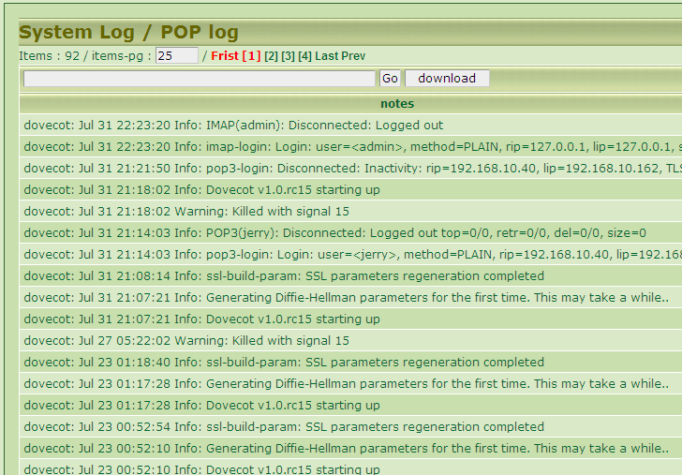
It’s a list of all the login records of the users through the Email softwares as imap , pop3 …etc.
All the records will be remained for one month.

Network Log
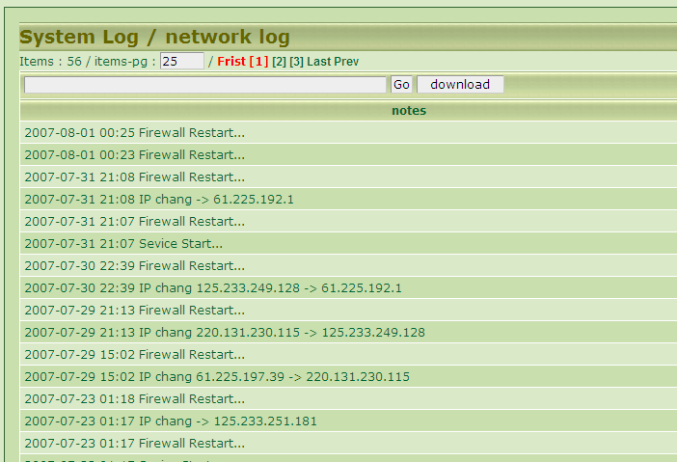
It’s the log of networking and firewall messages.

FTP Log
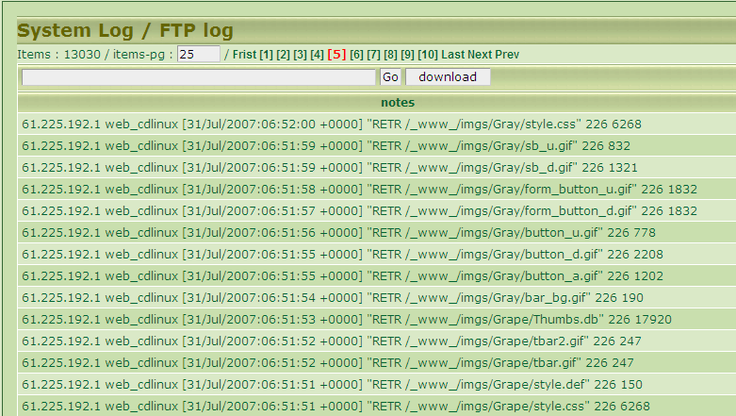
It’s the log of transmitting files by Virtual FTP.

Logout

Please do click the button 『Log Out』when leaving, if you use the public computer.

