Vigor和CiscoASA建立IPsec VPN Tunnel Lan to Lan Profile(Jinfat 提供)

假設CiscoASA的outside(WAN)是203.70.63.90,inside(LAN)是192.168.1.1/255.255.255.0

Vigor2910的WAN1是59.125.9.159,LAN是192.169.20.1/255.255.255.0

CiscoASA當撥入端,Vigor當撥出端,設定範例如下:

step1:

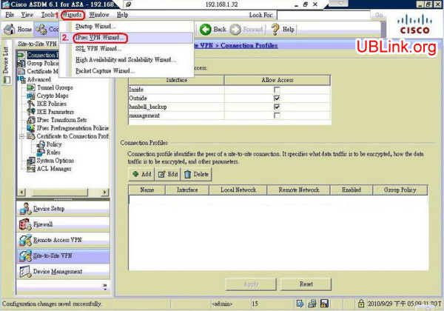  
step2:

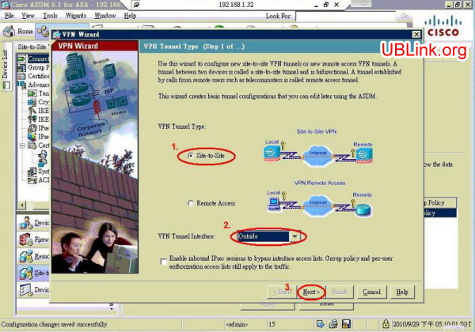  
step3:

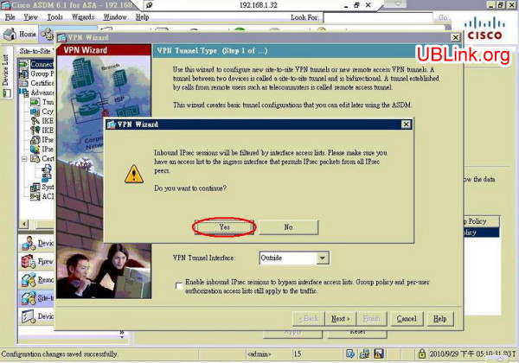  
step4:

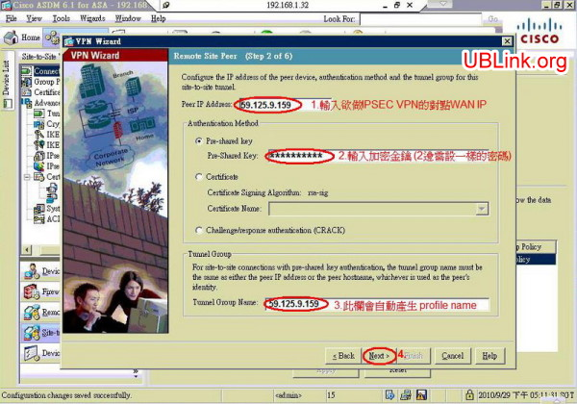  
step5:

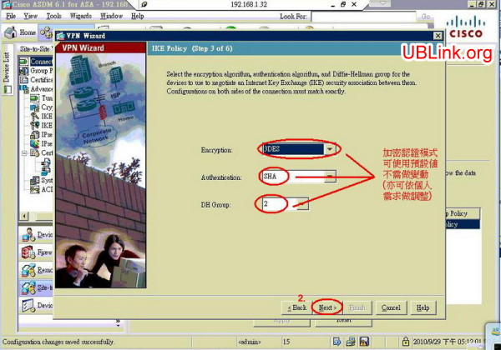  
step6:

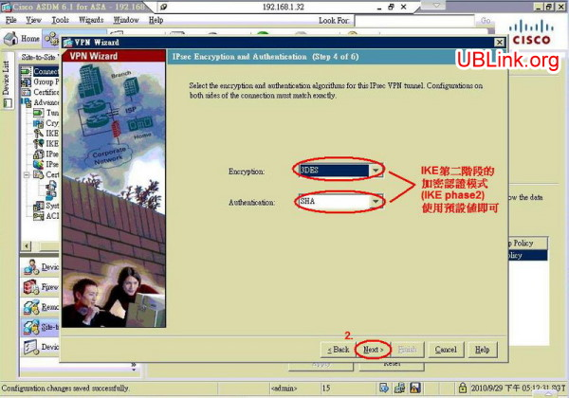  
step7:

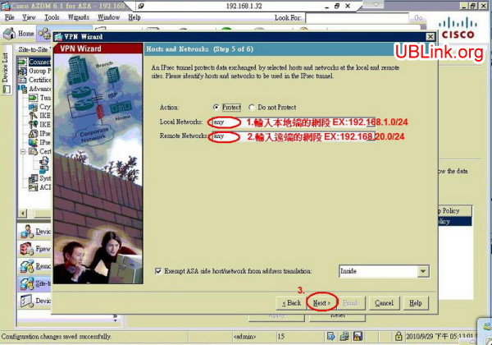  
step8:

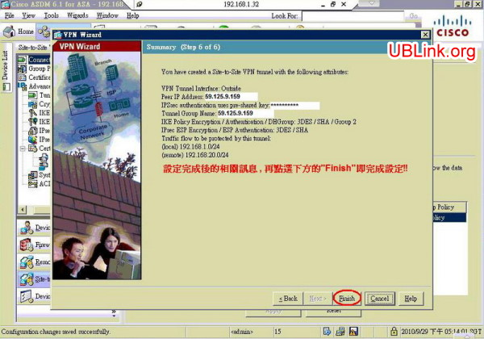  
step9:

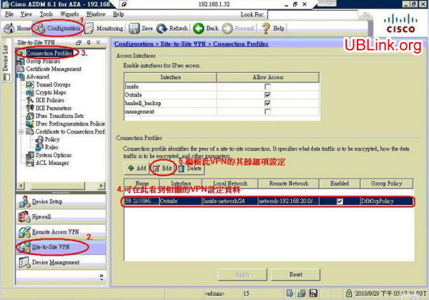  
step10:

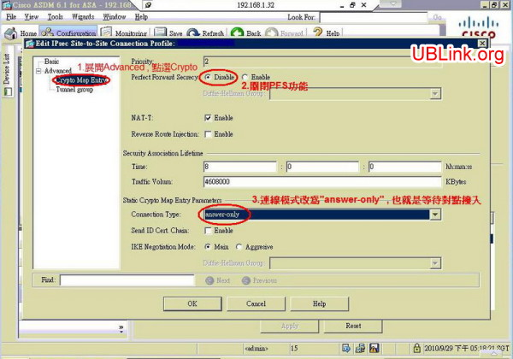  
step11:

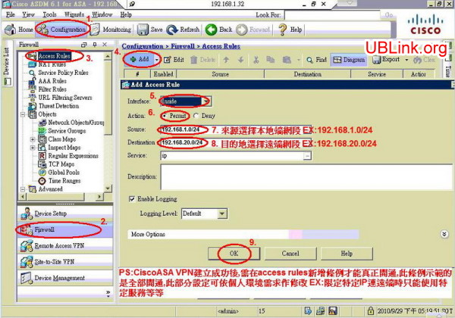  
step12:

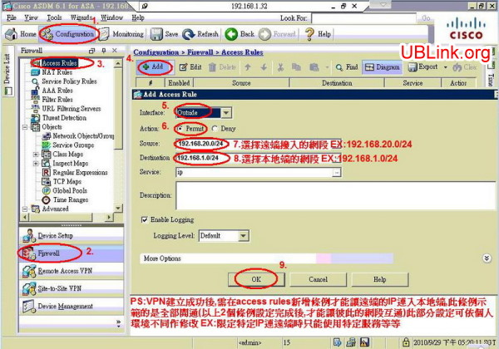  
step13:

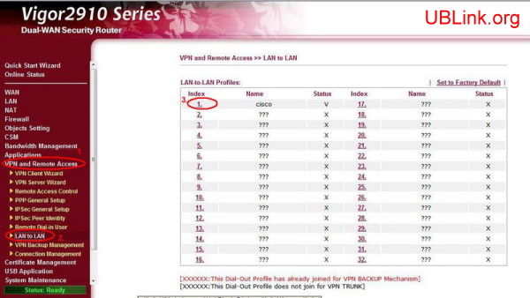  
step14:

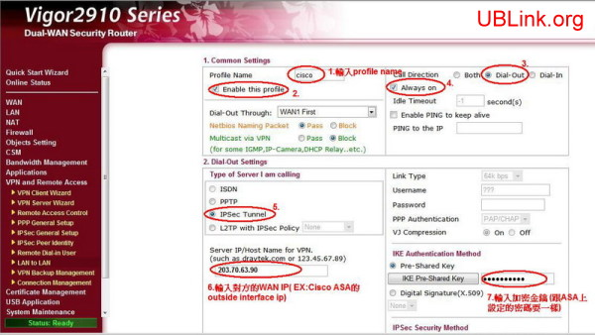  
step15:

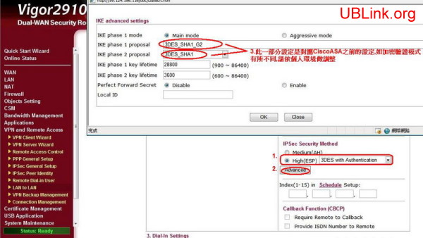  
step16:

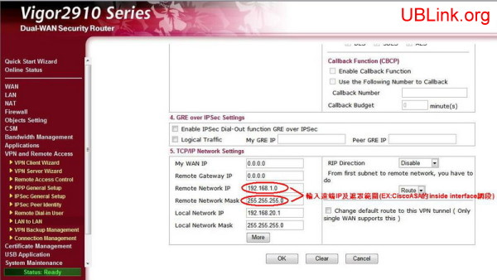

如對本產品還有其他問題

歡迎洽詢本公司各區服務處